Tab 1

Hydrogen Fuel-Cell Vehicle Development

ENGR090: Final Design Project

Michael Moran ’25 and Gabriel Salas ’25
Advised by: Carr Everbach

Swarthmore College, Department of Engineering
Swarthmore, PA

May 9, 2025
Table of Contents
Abstract 3
Introduction 4
Background 5
Previous Developments 5
Theory 7
Hydrogen Fuel-Cell 7
Galvanic Corrosion 8
Front Wheels Suspension 9
Hydraulic Brakes Inner Workings 10
Quick Release Steering Wheel Optimization 12
Rack And Pinion System Dynamics 12
Approach and Designs 13
Requirements and Constraints 13
Final Suspension Design 14
Hydraulic Brakes Development 19
Quick Release Steering Wheel Application 23
Rack and Pinion Integration 26
Conclusion 30
Suspension System Efficiency 30
Hydraulic Brakes 30
Steering Wheel Quick Release Efficiency 31
Rack and Pinion Development 31
Future Work 32
The Race To The Finish Line 32
Acknowledgments 34
Appendix 35
Sources 35
Spending and Budget 37
Additional Diagrams 38

Abstract

With rising concerns of carbon emissions and climate change, there have been increased efforts to reduce the damage done to the earth and the atmosphere in everyday life. A key area of concern is energy and the methods of producing it, with many efforts being concentrated in the automotive industry and finding alternatives to fossil fuels. One potential alternative is hydrogen. As such, this project proposed the continued development of a hydrogen powered vehicle with the ultimate goal of furthering the study into new renewable energy alternatives as well as the participation and victory in the Shell Eco-Marathon race. Swarthmore College has a long history of participating in the Shell Eco-Marathon, but the evolving competition rules have rendered the current vehicle design outdated and inadequate to compete. At the beginning of this project, the vehicle required significant modifications, including the front suspensions, hydraulic brakes, the steering system, the rack and pinion system, and the redesign of the cowl, all in order to meet the latest safety and performance standards. This year’s efforts resulted in the development and integration of a new double wishbone suspension system, the adaptation of new hydraulic brakes into a pedal, a quick release system for the steering wheel, and the improvement of the rack and pinion to fit new vehicle dimensions. All of this within the four months allotted for the project and also within budget. Using only $197.79 out of a budget of $800. The new designs aimed to address previous shortcomings and set a stage for future developments. This with the hope that the vehicle will be able to participate in the Shell Eco-Marathon in 2026 or 2027 the latest.

Introduction
The increasing effects of climate change are pushing for research and development in new renewable and clean energy sources. Although there are many areas for improvement in terms of reducing carbon emissions, the one currently in the spotlight is alternative fuels for automobiles. One such alternative is hydrogen. While electric vehicles are the ones rising in popularity as the vehicles of the future or the new standard for renewable energy, it is important to still explore other potential alternatives. Companies such as Hyundai and Shell are pushing for new developments in hydrogen powered vehicles. Hyundai with their N Vision 74, a hydrogen and electric powered hybrid sports car, and Shell with their Shell Eco-Marathon competition. The focus of this project is to continue the effort of developing a hydrogen fuel-cell vehicle (HFCV) fit to compete and win the prototype series of the Shell-Eco Marathon.
The Shell-Eco Marathon is a competition that aims to push the known boundaries of fuel efficiency technology through an unconventional racing competition. In this race, instead of trying to finish first, engineers focus on completing the race by minimizing the amount of hydrogen fuel used. The main events of the competition are individual races with a time limit with categories for both electric and hydrogen powered vehicles. After each run the fuel consumption of the vehicle is measured. The team with the highest mileage per gallon wins the competition. As such, the Shell Eco-Marathon is not a conventional race in the sense that time and speed are not of much importance. Instead, the focus lies in the fuel consumption efficacy of the vehicle. The competition provides a platform for engineering students to develop and design their own highly efficient vehicle to pave the way for sustainable energy technologies.
The philosophy behind Shell Eco-Marathon traces back to 1939, when Bob Greenshield, in a friendly competition amongst his colleagues, designed and built a vehicle that traveled farthest while using the same amount of fuel as his competitors. Nearly a century later, the competition stands with the challenge that aims to question and revolutionize fuel efficiency: “How can we travel the farthest using as little energy as possible?” Tasked with this challenge, the team delved to develop a vehicle that would push the boundaries of fuel efficiency and vehicle design.

Background

Previous Developments
2009: The original inspiration for the hydrogen fuel-cell vehicle was actually a motorcycle. Designed by Alex Bell’09 and Andres Pacheco’09 with the advice of Professor Nelson Macken, the hydrogen fuel-cell motorcycle tackled the issue of the efficiency of using hydrogen. With developments to attempt and improve the transportation of the hydrogen into the fuel-cell, as it was found that significant proportions of hydrogen would remain in the tank after it depressurized. This was done to try and increase the runtime of the system.
2013: The first (recorded) effort to develop a hydrogen fuel-cell powered vehicle for competition in the Shell Eco-Marathon. Designed by Eric Verhasselt’13 and advised by Professor Nelson Macken. This project took approximately a year and a half and saw the complete development of a vehicle capable of placing 3rd place at the competition. With a chassis design made of aluminum for its lightweight and strength and focused on maintaining the center of gravity of the vehicle centered and slightly tending to the rear. This chassis would continue to be used for future developments of the vehicle with slight alterations. The original vehicle also sported a steering system with a combination of Greenspeed trike style wheel hubs and tadpole trike style linkage for efficiency and space saving. The braking system consisted of a Strummey Archer hub brake for the front wheels and a generic ‘V’ style brake for the rear wheel. The canopy of the vehicle was made with fiberglass and it was designed to balance weight, have a low drag coefficient, and possibly generate lift. Although many improvements to the vehicle would be made, this initial development and completion of the vehicle served as a tremendous and strong basis for future projects.
2018: The 2018 team made further improvements in the already existing vehicle. Added a suspension system, optimized the chassis, and changed the steering system. Changes to the cowl of the vehicle were also made during this period. The team was able to attend the 2018 Shell-Eco marathon competition and went as far as passing inspection. However, an issue with the safety off switch of the fuel-cell prevented the team from competing.
2024: After a few years of being out of commission, the 2024 team started the revitalization effort for the HFCV. This involved testing for optimization of the fuel-cell, reviewing the Shell Eco-Marathon rules for outdated vehicle specifications, and finding ways to reduce the weight of the vehicle. This is where testing and developments for the new carbon fiber components for the chassis were made. Although the team was unable to compete, they were able to lay a plan and a path forward to bring the vehicle back to competition standards.

Starting Vehicle
The current chassis of the vehicle is composed of aluminum beams and plates, making it quite heavy and inefficient. The new proposed chassis will be composed of mostly carbon fiber parts and aluminum joints with 3D printed collars. This decision comes from the results found by the 2024 senior team on the effectiveness and benefits of each material they tested. With wrapped carbon fiber and 3D printed collars being the most fuel efficient and resistant materials. The new chassis will follow the previous design, but as a result of the new materials used it will end up being slightly larger. This will be beneficial for the project as it is also planned to integrate a second floor to the chassis to cover the steering system and provide more comfort and safety to the driver.
The hope of this project was to develop new and improve systems for the suspension, braking, and steering of the vehicle.

Theory

Hydrogen Fuel-Cell
As stated in the name, the hydrogen fuel-cell vehicle utilizes a fuel-cell as its main power source. The way a hydrogen fuel-cell is able to generate electricity is by effectively being a battery. It is composed of an anode, an electrolyte, and a cathode. The anode contains a catalyst that when fed hydrogen molecules it separates them into electrons and hydrogen ions. The hydrogen ions are able to travel freely through the electrolyte and into the cathode, where air is being fed into the system. Meanwhile, the electrons are fed into a circuit where the main motor is connected, effectively creating an electric current and generating power to drive the vehicle. At the end of the process the electrons reunite with the hydrogen ions as well as with oxygen from the air, producing heat and water vapor. The process is considered environmentally friendly as it produces no carbon emissions so long the process for collecting and storing hydrogen is also eco-friendly.

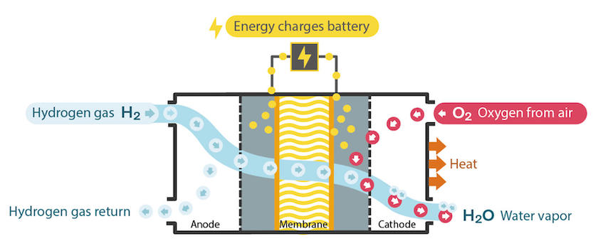
Figure 1. Image portraying the inner workings of a hydrogen fuel-cell. The hydrogen gas is fed in through the anode where a catalyst splits the molecules into electrons and hydrogen ions. The hydrogen ions are free to pass through the membrane (which can be an electrolyte) and go to the cathode. Meanwhile, due to their negative charge, the electrons go through a circuit where they generate an electric current powering a motor or battery. At the end, the electrons reunite with the hydrogen ions and bond with the oxygen from the air being fed into the cathode. This creates water vapor and heat as a byproduct of the process.

The inner workings of a hydrogen fuel-cell are more complex than the explanation given here. However, for the purposes of this project an elementary understanding of how the vehicle is able to generate power is all that was needed as no direct modifications, additions, or testing to the fuel-cell were made.

Galvanic Corrosion
One of the greatest challenges for this project was finding the best parts for the designs. This is due to the incompatibility of certain metals with one another. The majority of the new additions made to the vehicle were made from aluminum as it is a light and strong material. Aluminum, however, is affected by galvanic corrosion when in contact with steel which is the most common material for which screws, nuts, and other types of connections are made out of.
Galvanic corrosion in the simplest of terms is the acceleration of corrosion in one metal due to its contact with another metal. This is induced by the presence of an electrolyte (i.e. water). Galvanic corrosion is an electrochemical process. It happens because the two metals effectively act as a battery when water or another electrolyte is present. Differences in the corrosion potential of the metals (or how likely one metal is to take electrons from another) causes one metal to take electrons from the other, using the water as a wire/circuit. The loss of electrons is what causes corrosion. Thus, in this process the less noble metal/the one with the higher corrosion potential begins to lose electrons and therefore begins to corrode. Meanwhile, the more noble metal goes through a process called cathodic protection which means that the gain of additional electrons helps it last longer and corrode more slowly.

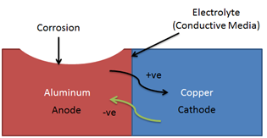
Figure 2. Image representation of galvanic corrosion. The anode (aluminum) loses electrons to the cathode (copper or steel) thanks to the connection made by the electrolyte. This causes corrosion in the anode while the cathode is protected due to the gain of additional electrons.

In the case of this project, aluminum is the less noble material when compared to steel. Thus, combining aluminum components with steel components could lead to accelerated corrosion in the vehicle and reduce its overall durability. It could also affect future developments as corroded parts would have to be completely replaced.

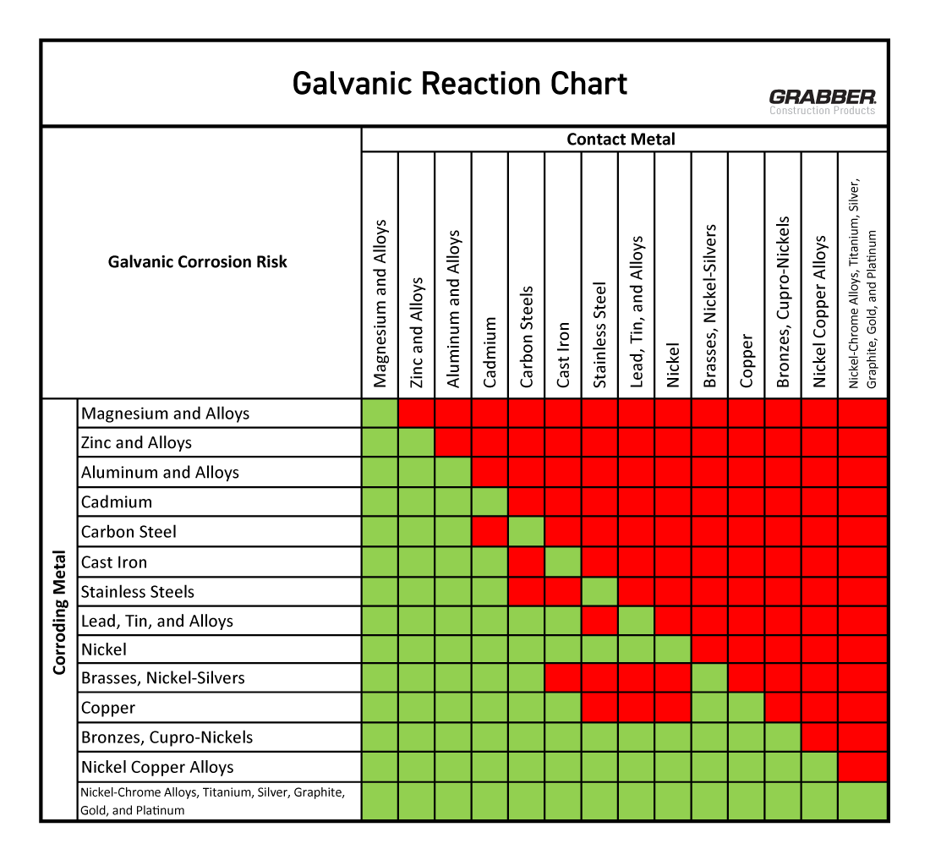
Figure 3. Chart representing which metals create a galvanic corrosion reaction when in contact under an electrolyte. The chart shows that steel and aluminum create a galvanic corrosion, with aluminum acting as the corroding metal. Meanwhile, zinc does not create a galvanic reaction with aluminum,

To solve this issue, it was opted to prioritize steel components with some kind of coating or plating. In this case, zinc plating was found to be the best material to combine with aluminum. This is due to their similar corrosion potential which means that contact between the two would not induce galvanic corrosion. Instead, the zinc would protect the aluminum as it would become a sacrificial metal. However, not all the parts that were needed were available zinc plated. Thus, the recommendation for this was to make sure the surface ratio between the less noble metal to the more noble one is above 10:1. This is to minimize galvanic corrosion as much as possible.

Front Wheels Suspension
Previous issues with vibrations due to the improper shock absorber as well as a lack of options for modifications led to the need for a new suspension system. This led to the selection of the double wishbone suspension, as it is one of the most common models due to its higher camber control and greater range of motion. However, due to its complexity it can be more expensive than other types of suspensions. It also needs fine tuning to be properly aligned and can reduce ground clearance. The latter can be seen as a benefit as seeing as this project is for a competitive vehicle, lower ground clearance allows for greater mobility as well as less drag.

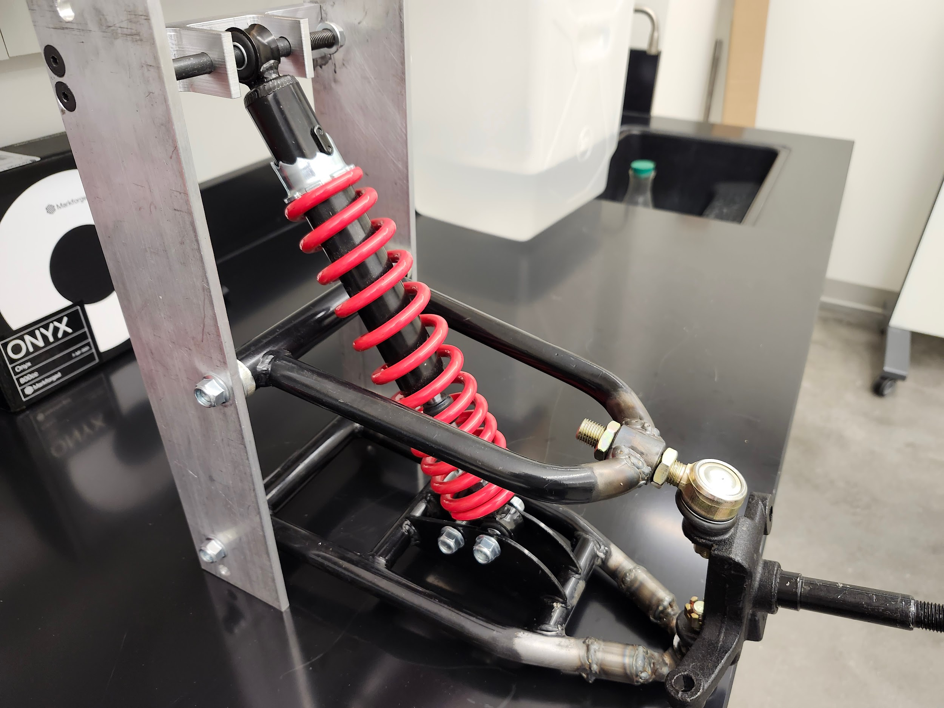
Figure 4. Image of double wishbone suspension attached to the suspension plate to be connected to the vehicle’s frame. Lower wishbone is connected to the shock absorber through a shoulder bolt while the shock absorber is connected to the suspension frame through another shoulder bolt. Main axle/connection to the wheel is seen sticking out of the table on the right side of the image.

The shoulder bolts connecting the wishbones to the suspension plate act as pinned supports, allowing the wishbones to rotate as the wheel moves up and down. This movement is what compresses the shock absorber, which absorbs the energy from vibrations or change in altitude experienced by the wheel. The shoulder bolts connected to the shock absorber also act as pinned supports. This allows the shock absorber to also rotate with the wishbones, which assures that the spring always experiences the forces from the wheel in its vertical axis.

Hydraulic Brakes Inner Workings
The Shell-Eco Marathon regulations require that the vehicle have a hydraulic braking system for each axle of the vehicle. This can be attributed to safety concerns, as hydraulic brakes are more consistent, have high stopping power, are more durable, and have efficient heat dissipation when compared to cable brakes or even drum brakes (which is what the previous vehicle was equipped with).
A hydraulic disk braking system involves the use of a master cylinder, brake calipers, hoses/lines, and disk rotors. The system works by applying force to the master cylinder which compresses the brake fluid and creates hydraulic pressure. This pressure is transported through the hoses and into the brake calipers, which contain two small pistons on each side. The pressure from the brake fluid causes the pistons to move and exert pressure on the disk rotor, which ultimately causes the wheel to stop turning.

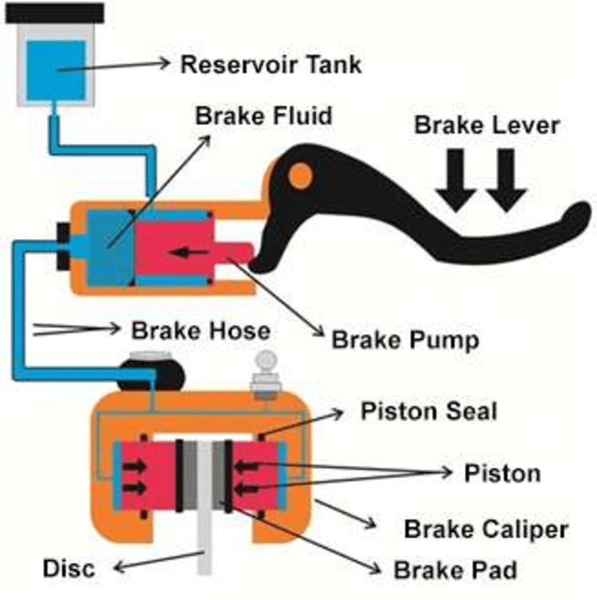
Figure 5. Diagram of the inner workings of a hydraulic disk brake. It demonstrates how the piston (brake pump) pushes the hydraulic fluid through the brake hose which causes the pistons in the brake calipers to push against the disk. Using friction to slow down the wheel.

It is important for the master cylinder and the brake calipers to be compatible with each other, as incompatibility could cause inconsistent braking, wear and tear, and ultimately failure of the system. The amount of pressure exerted by the master cylinder is heavily dependent on its bore diameter as it is what determines the amount of brake fluid that the cylinder can displace. A larger bore diameter means more fluid displaced which means more pressure acting on the pistons of the brake calipers. This can create more braking power, but it is possible that the pressure can overwhelm the calipers if they are not designed for it and cause damage in both the calipers and the disk rotor. An opposite effect could also happen. If the bore size is too small it might be unable to create enough pressure to effectively move the pistons in the calipers, and thus reduce the stopping power. Another aspect to note is that the synergy of the master cylinder and the brake calipers can impact the feel of the brake, making it feel too heavy or too light if the components are incompatible. It is for these reasons that it is often recommended to use a hydraulic disk brake system with components from the same brand, as they are designed to be compatible.

Quick Release Steering Wheel Optimization
A quick release steering wheel is a detachable steering wheel system that is primarily used in motorsports, such as Formula 1 (F1). The system is composed of a specialized hub and coupling mechanism that lock and unlock a steering wheel in place. This allows for a driver to easily detach and attach the steering wheel without using excessive force or tools. The primary purpose of a quick release system is to provide safety and convenience in the event of an accident. In the case that an accident occurs, the quick release mechanism allows the driver to detach the steering wheel within seconds to ensure a quick and easy exit from the vehicle. It is essential that a driver must be able to exit the vehicle without obstruction in motorsport competitions. Therefore, the integration of a quick release steering system in the HFCV was necessary.

Rack And Pinion System Dynamics
As stated in the competition rules, under Article 32 Steering, it is essential for the vehicle to have a modern steering mechanism that must allow for both hands to be used when driving. This is done to increase the overall safety of vehicles and to provide a modern update. Through the development of a modern steering system it ensures proofness for competition standards and future development. The mechanical principle of a rack and pinion steering system converts a steering wheel's rotational motion into linear motion, that is needed to turn a vehicle’s wheels. The pinion, which consists of circular gears that mesh with a flat toothed component known as the rack, is what allows for the circular motion to be converted into linear motion. When the steering wheel is rotated the pinion rotates, moving the rack latterly either to the left or right. The lateral movement is then transferred through tie rods to the steering wheel, causing the wheels to pivot accordingly in the direction intended. Power assisted systems, such as a hydraulic power steering (HPS) reduces the drive’s required work by providing additional force to the rack's internal motion. This along with aspects such as the steering ratio and Ackermann geometry ensures optimal conditions for operation. This is pivotal according to the competition’s rules as it provides additional safety factors derived from responsive handling via smooth steering control. Together, the components combined provide a refined system that is safe and reliable.

Approach and Designs

Requirements and Constraints
This project involved many requirements and constraints. Both were dependent on the previous work done on the vehicle and new rules and regulations by the Shell Eco-Marathon. Below is a list of the requirements and constraints for the project as well as a list of the specific rules from the competition that were significant.

Table 1. Requirements and constraints involved in the HFCV project.
Requirements | Constraints
- Develop new suspension system for the vehicle  - Develop new brake system in a pedal format for front wheels  - Must be a hydraulic system  - Integrate rack and pinion steering system  - Vehicle should be capable of doing a 90 degree turn within a radius of 8 meters  - Steering wheel must be easily removable for accessibility/exit  - All developments should be additions or modifications made for the current vehicle | - $800 budget  - Approximately 4 months of development  - New suspensions are double wishbone suspensions, must be fitted to new vehicle  - Brake types are limited to those that fit bicycle wheels  - Size of steering axle is dependent of width of chassis and length of new suspensions  - Limited space due to chassis design  - Additions have to be big enough to be usable but small enough to fit in frame  - Additions should be as light as possible to not significantly increase the vehicle’s weight.

Table 2. List of significant rules and regulations of the Shell Eco-Marathon 2025.
Article 30 | “It is imperative for Drivers, fully harnessed, to be able to vacate their vehicles at any time without assistance in less than 10 seconds.”
Article 32 | “Steering must be operated predominately through the front wheels.”  “The steering mechanism must be precise and intuitive.”
Article 39 | “The maximum vehicle weight (excluding the Driver) is 140 kg.”
Article 42 | “The external wheel of the vehicle must be able to follow a 90° arc of 8 m radius in both directions.”  “The steering system must be designed to prevent any contact between tyre and body or chassis.”
Article 43 | “Vehicles must have two hydraulic braking systems, one per axle. Brakes that act on the tyres are not permitted.”  “The front brake(s) must have a single foot operated pedal controlling front wheel(s)”

To follow these requirements and constraints, the team developed a few philosophies that were followed when designing each new addition to the vehicle. This included:

- Each new addition should add as little weight as possible to the vehicle. This is to not compromise the weight that was cut by switching to a new carbon fiber frame, which should improve the efficiency of the fuel cell and make the vehicle more competitive. If the vehicle weighs too much it could also lead to disqualification.
- Additions must be easy to manufacture. Adding complexity to the designs could add unnecessary weight aside from making the replicability of the work more difficult.
- Additions should be easily accessible/easy to maintain. Since the hydrogen fuel-cell vehicle is designed for competition, it should be easy to repair and easy to access important components. The vehicle should also be able to last multiple races and multiple teams.
- Replaceable and/or modifiable. Many of the struggles of this project had to do with the constraint that developments must be fitted to the already existing vehicle. This led to limitations in creativity and developments. Thus, to minimize this issue for future teams any new developments must be able to be easily modified or replaced.

With these philosophies in mind, the team was able to make new developments for the steering, braking, and suspension systems of the vehicle in the hopes of one day having a competition ready car.

Final Suspension Design
The actual suspension system for the project was bought during the summer of 2024 and it was designed for an all terrain vehicle. Thus, the goal was mainly to find a way to integrate the suspension into the new vehicle chassis design. However, slight modifications were made to the suspension as it was needed.
The first modification was to cut and weld the connectors to the axle, as originally these were slightly curved to increase the clearance between the vehicle and the ground due to its all terrain nature. However, since the HFCV is a competition vehicle and it will only be participating in a flat steel slag road, a lower clearance is desired to lower the center of mass of the vehicle and increase its turning agility. Thus, the wishbones were cut at the ends and welded together using a metal tube as the in-between material to realign the connection with the axles. The second modification was to cut and extend the main rod of the axle, as early in the integration process it was found that the rod was too short and too thick for the wheel hub. Thus, making a new piece for the wheel to connect properly to the axle was necessary.

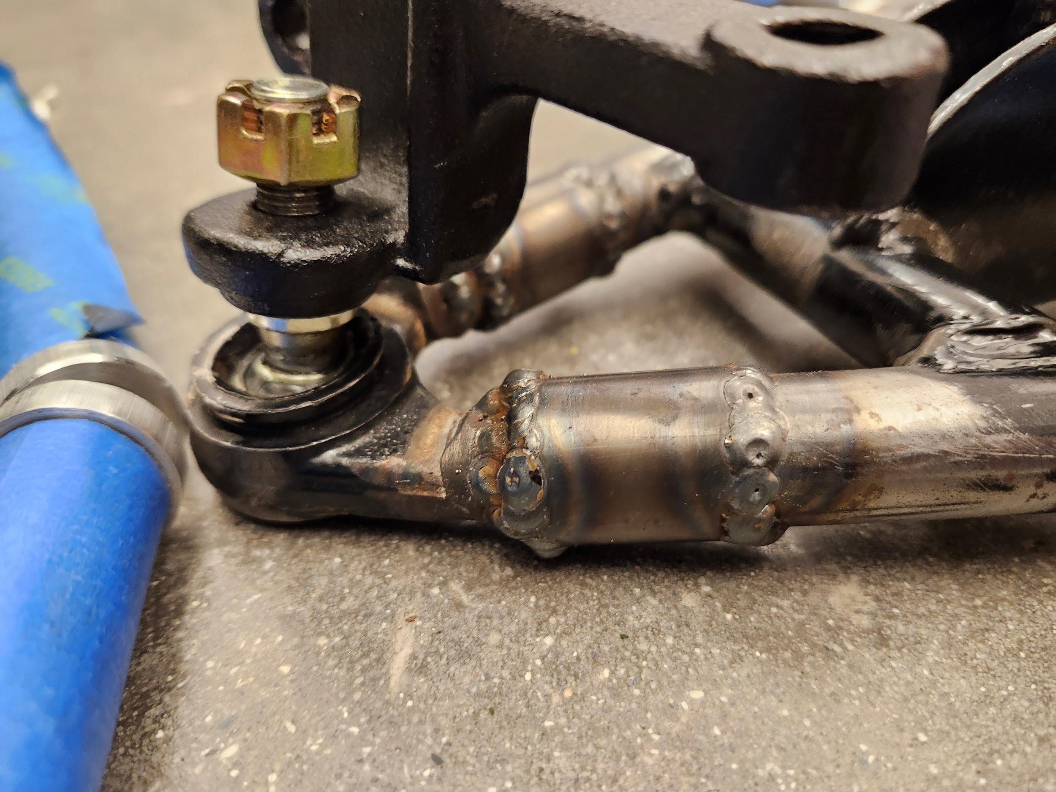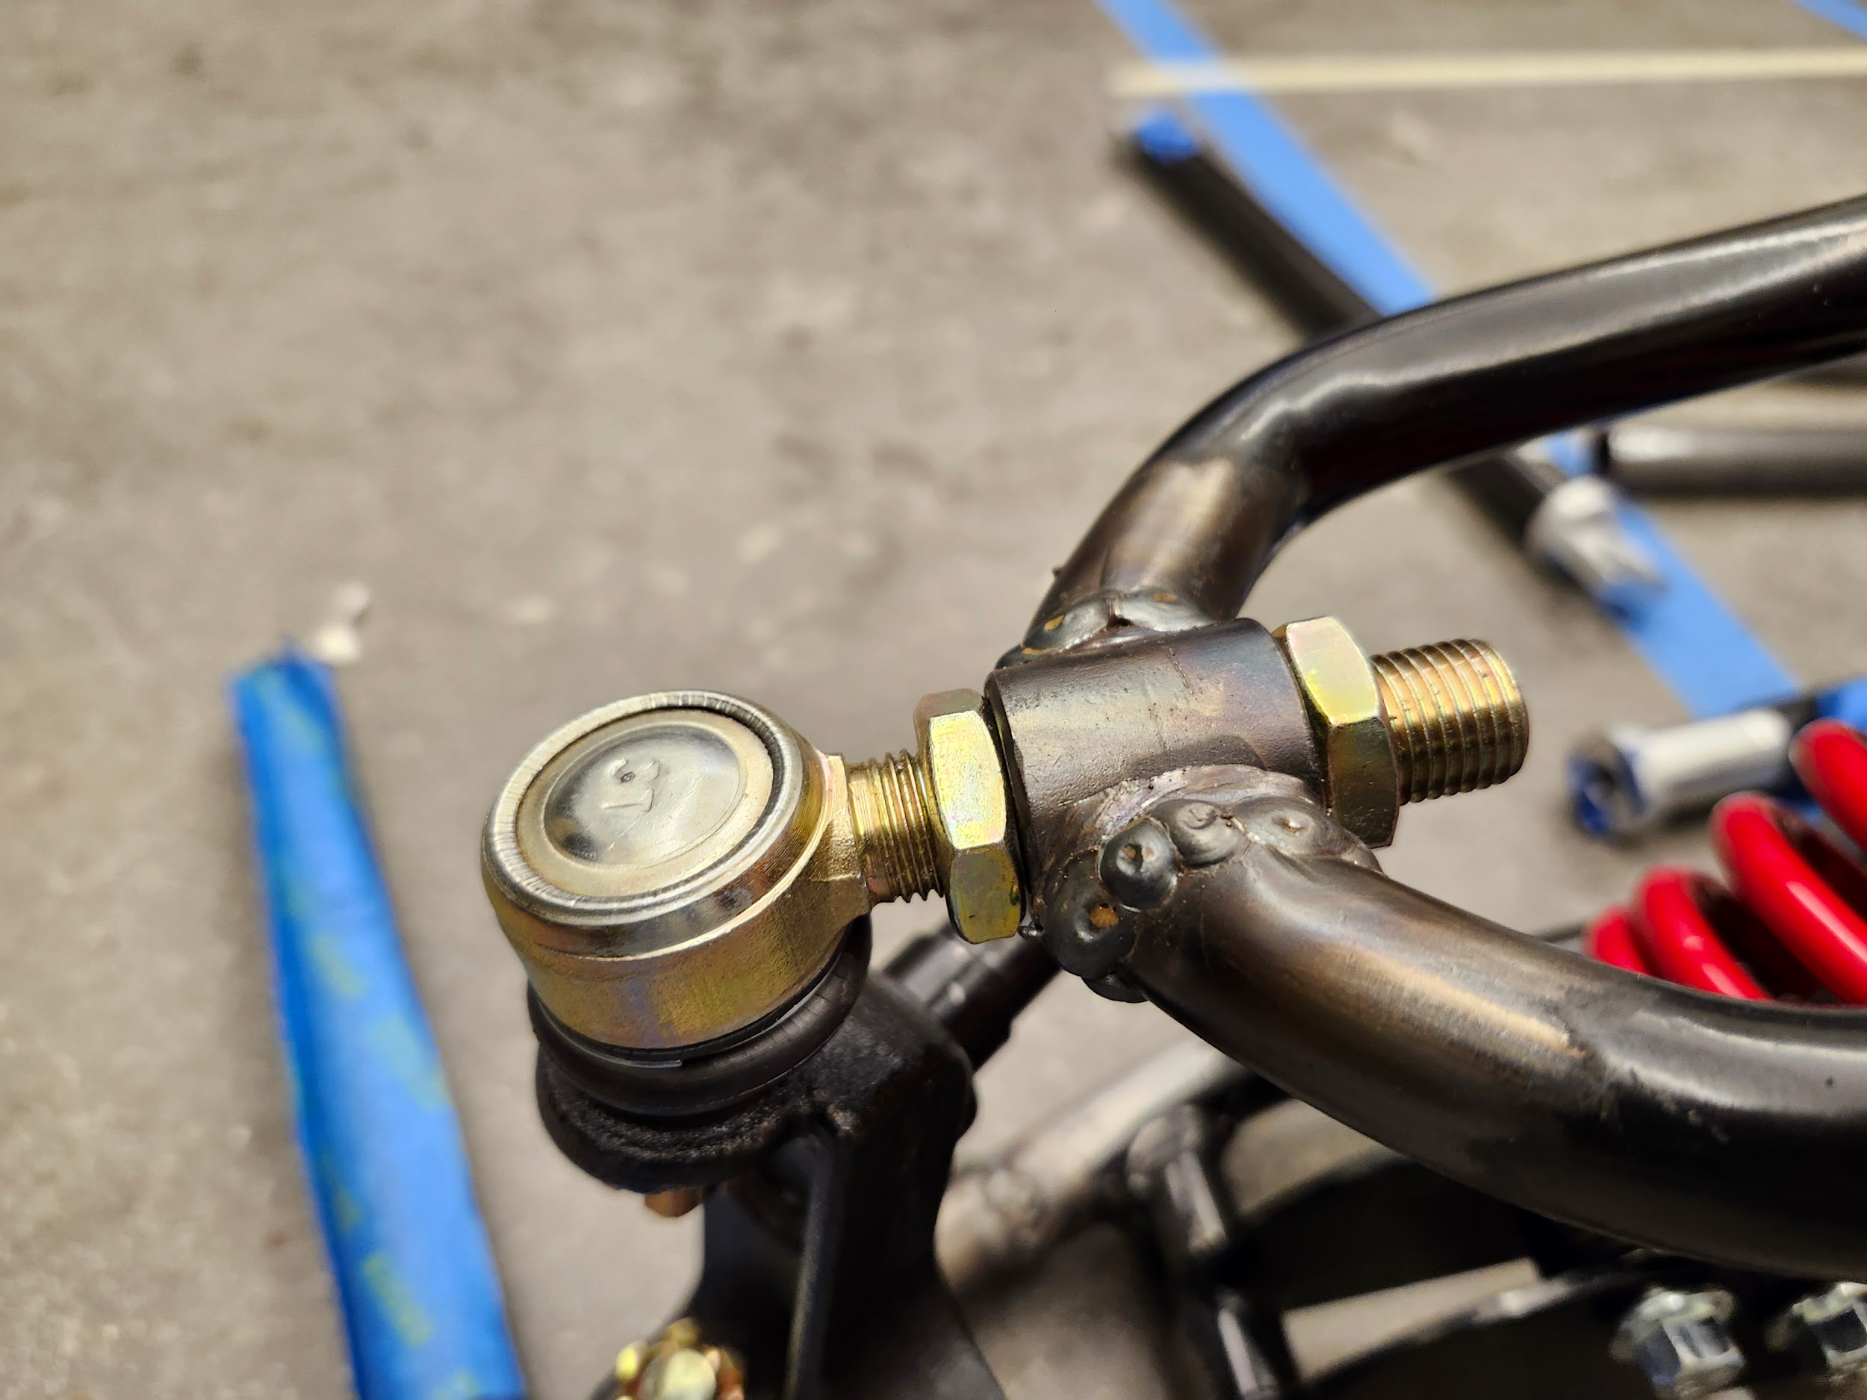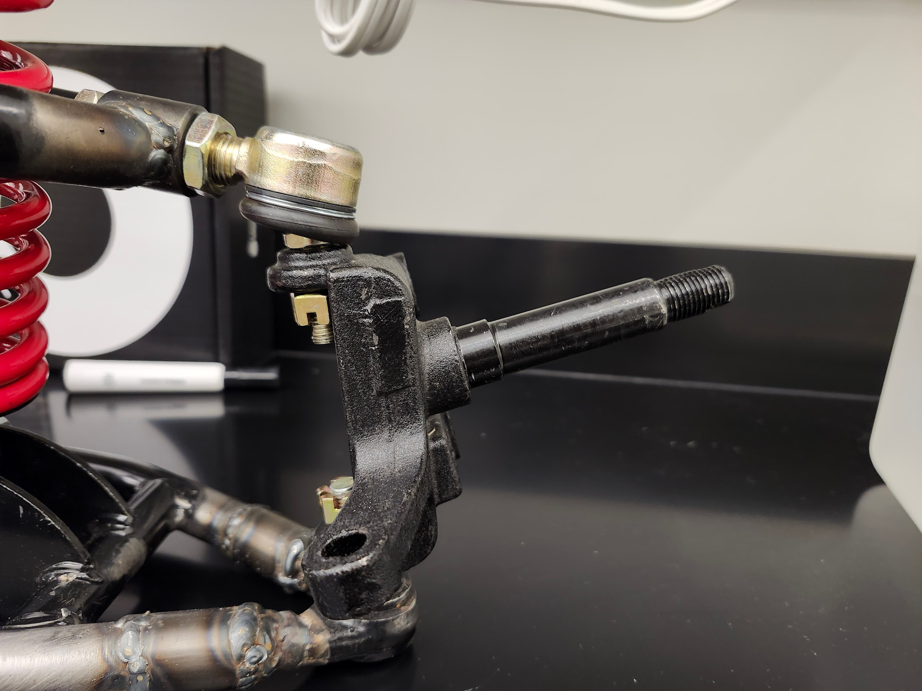
Figure 6. Images of modifications done to the suspensions. The left and middle images portrait the welding done to straighten the sections of the wishbones connecting to the axle. The image on the right shows the main axle (what connects to the wheel). This still requires further modification to make it longer and thinner in order to fit the wheel’s hub.

For the actual integration of the double wishbone suspension into the chassis, an aluminum plate was designed. This consisted of two 0.25 in thick plates that stand 15 in tall and a 6.70 in long connector that goes in-between the two plates. The width of the connector is dependent on the width of the wishbones and it also serves as the main holder for the shock absorber.

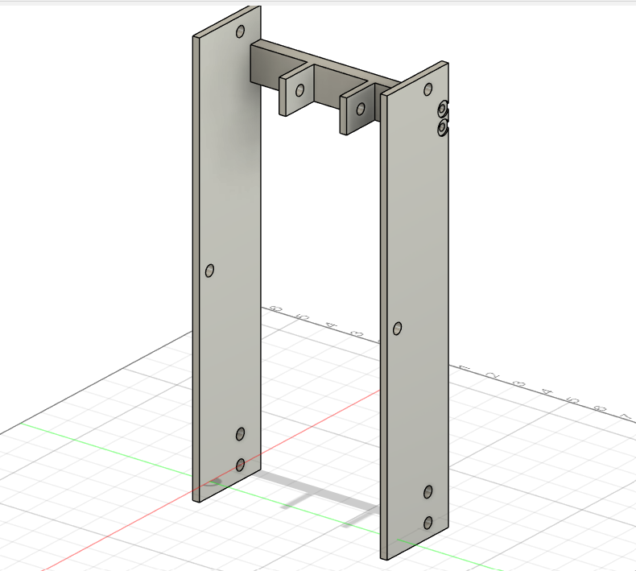
Figure 7. Plate design to connect suspension to the vehicle’s frame. Two quarter-inch thick plates standing at 15 inches and 3 inches wide connected by a 6.70 inch long connector. The connector is half an inch thick and 1.20 inches tall with 1.375 inch long, quarter-inch thick flaps that allow for a shoulder bolt to hold the shock absorber.

The plates are designed to connect to the frame via two bolt holes, one is half an inch from the bottom edge and the other is 14 and a half inches from the bottom edge with both being 1 inch away from the right edge. Only the bottom and the right edges were used for hole placement due to possible imperfections in the height and width of the plates when manufacturing. Using one edge for each orientation allows the distances between connections to remain unchanged, which is important for everything to fit well once assembled.

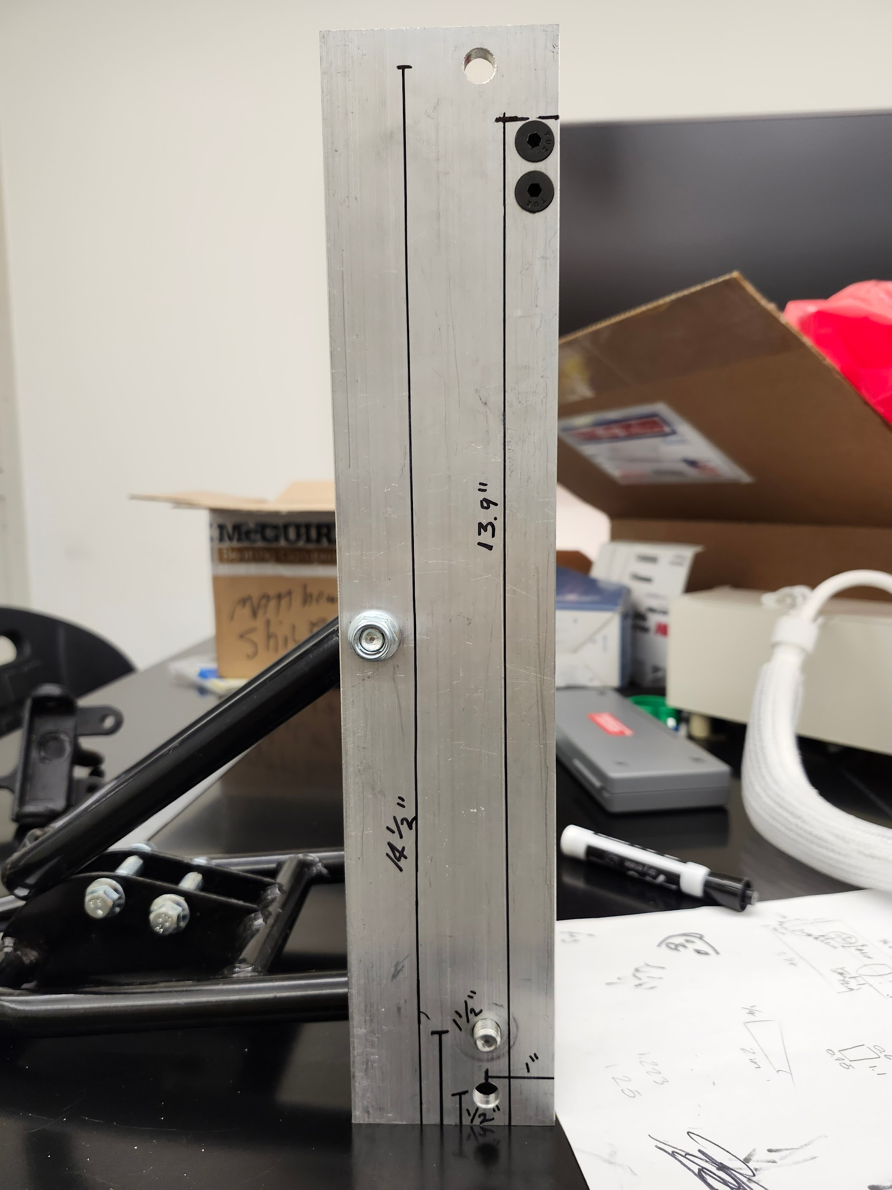
Figure 8. Image showing the measurements for the placement of the holes for the bolts/screws. Only the bottom and right edges were used when manufacturing and making measurements to account for imperfections in the dimensions of the plates. This kept the distances between components unaffected.

The suspension connects to the frame through two holes with a direct distance of 6 inches. One hole is 1.5 inches from the bottom edge and 1 inch from the right edge while the other hole is 2.5 inches from the right edge. This is to make sure that the suspension as well as the frame are able to be connected/disconnected freely without having to take both apart. It also gives the wishbones more space to rotate.

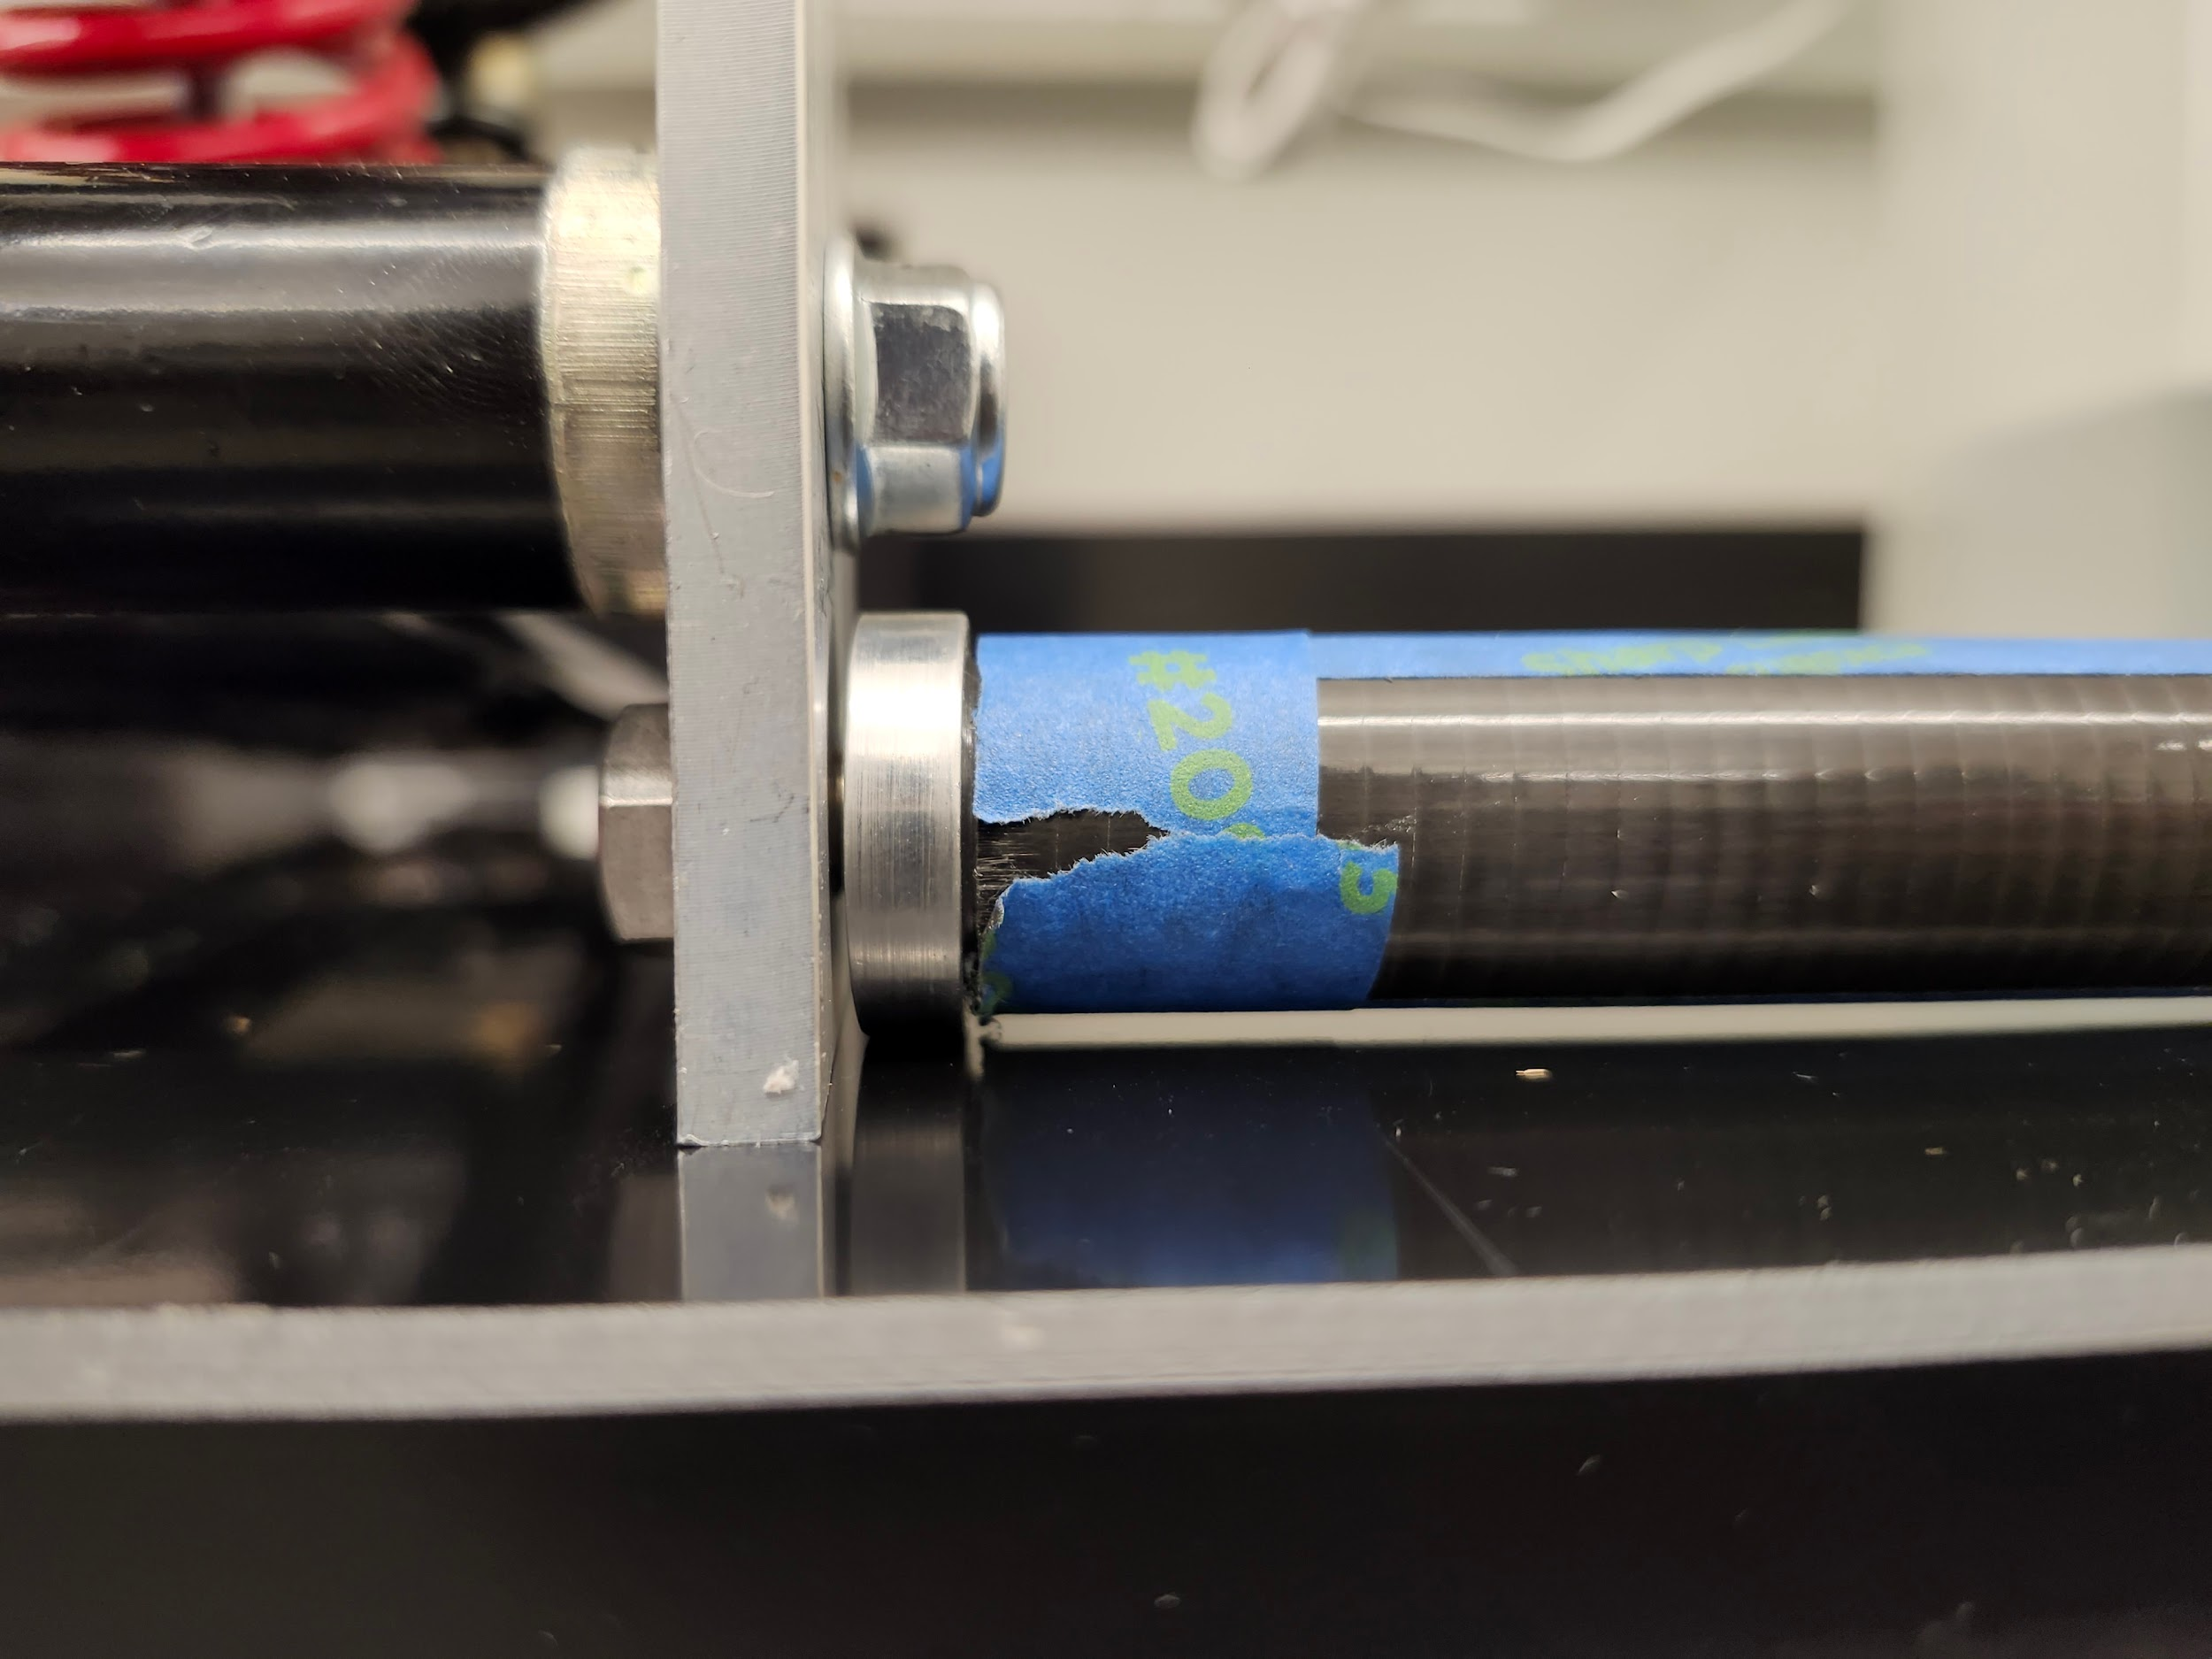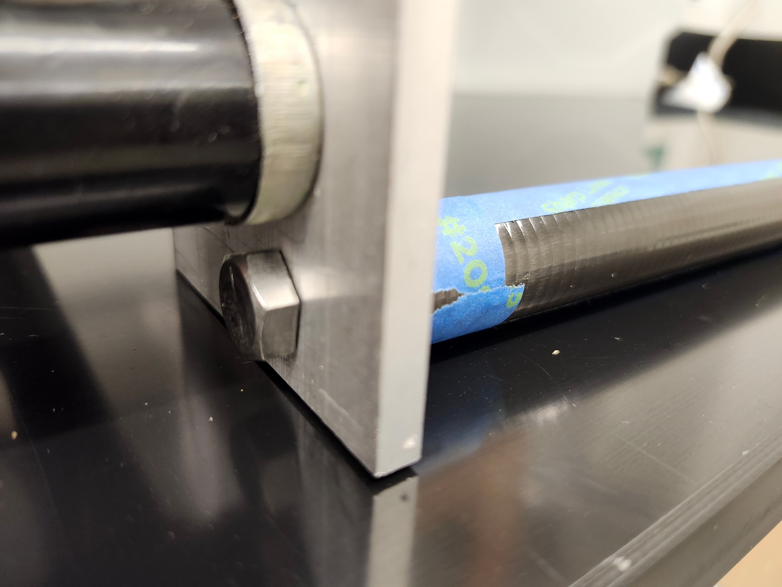
Figure 9. Images of suspension connection (top) and frame connection (bottom) to the suspension plate. The image shows how both connections don’t interfere with each other and one is able to access and disassemble each component without needing to take the other apart.

Finally, the connector is placed with a distance of 13.90 inches from its top edge to the bottom edge of the plates. This distance from the bottom edge means that naturally the suspension will be pointed downwards due to the length of the shock absorber. The reasoning for this is that as it is installed onto the vehicle and the driver gets on, the shock absorber will be compressed due to the weight and thus it will want to point upward as it is pushed down from its connections on the suspension plate. The hope is that the suspension will stand parallel to the ground as it handles the weight of the vehicle and the driver thanks to its naturally pointing downwards position. If this is not the case, or if the height of the vehicle needs to be adjusted, the location of the connector can be changed easily by simply drilling new holes for where it’s new desired position should be. This connector was initially planned to be welded to the two side plates. However, this was deemed too difficult to replicate and could be easily done wrong. It would also prevent future modifications. As such, it was decided instead to screw the connector and the plates together, using two screws on each side to increase the strength of the connection and also prevent the rotation of the piece.
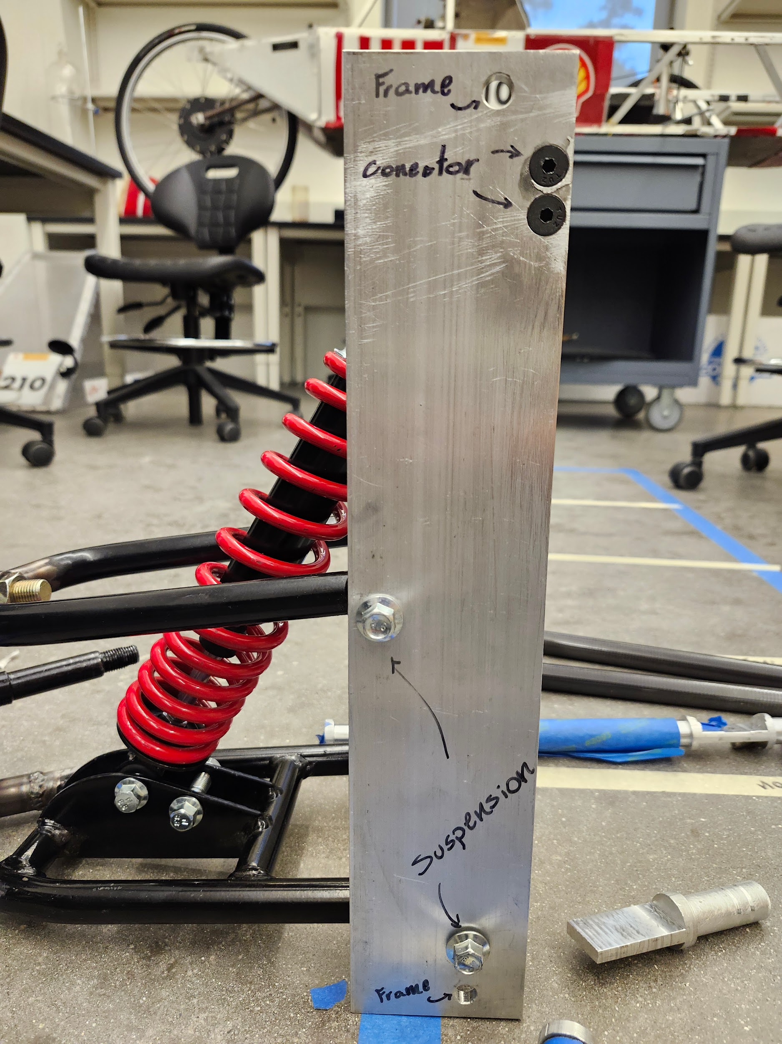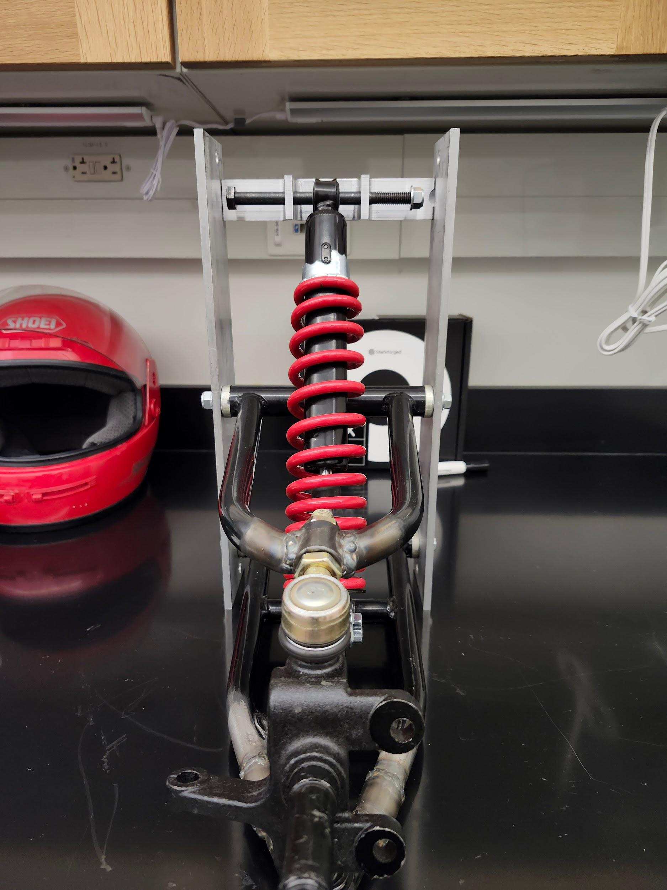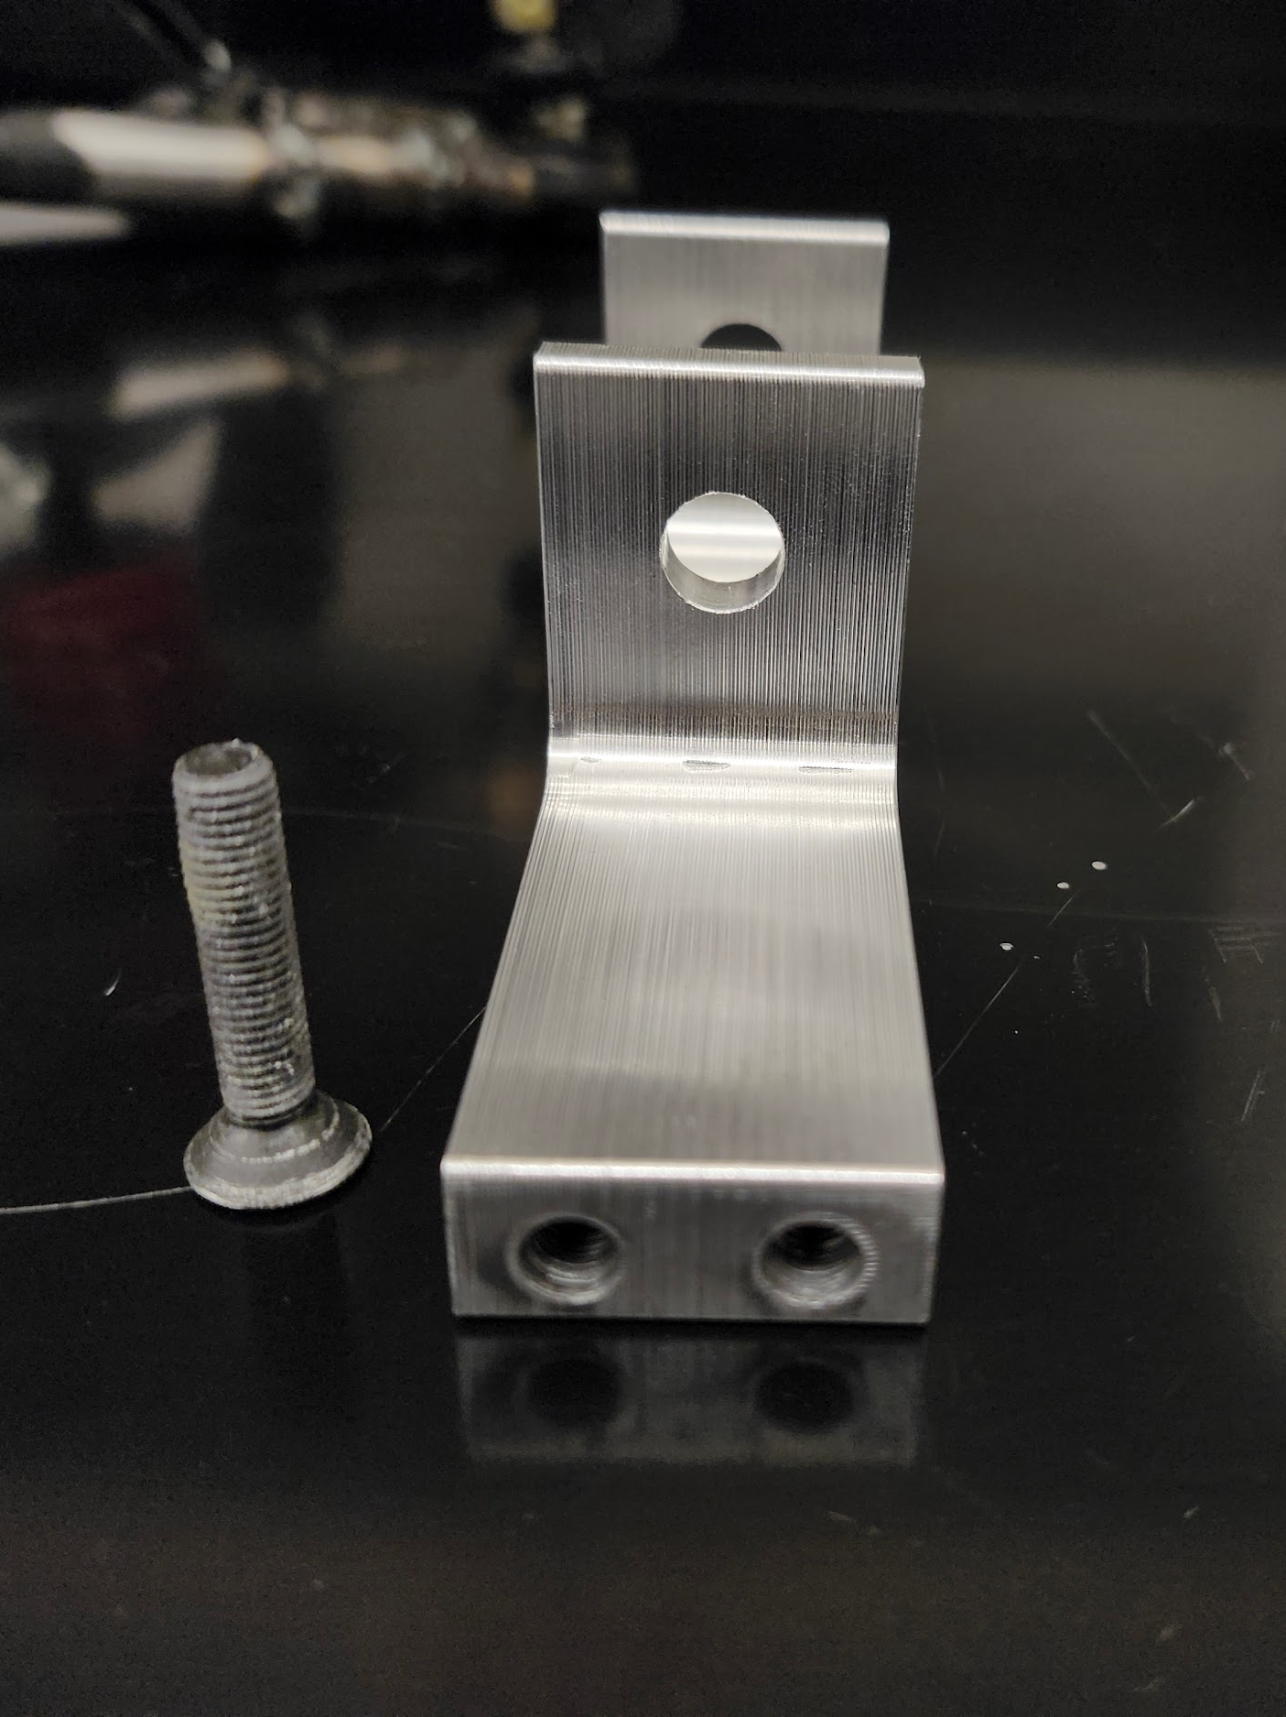
Figure 10. Images of fully assembled suspension (left and middle) as well as disassembled connector with screws (right). A shoulder screw holds the shock absorber in place in between the connector’s clips. The connector is attached to each suspension plate by two specialized screws resistant to vibrations.

Hydraulic Brakes Development
As per the new Shell Eco-Marathon regulations, all the brakes in the vehicle must be hydraulic brakes. The previous HFCV team (spring 2024) had already begun the process of transitioning the drum brakes in the vehicle to new hydraulic brakes. They were able to integrate a disk hydraulic brake system onto the rear wheel using the Shimano MT-200 hydraulic bike brakes and also a 3-D printed stand to hold the calipers to the disk.

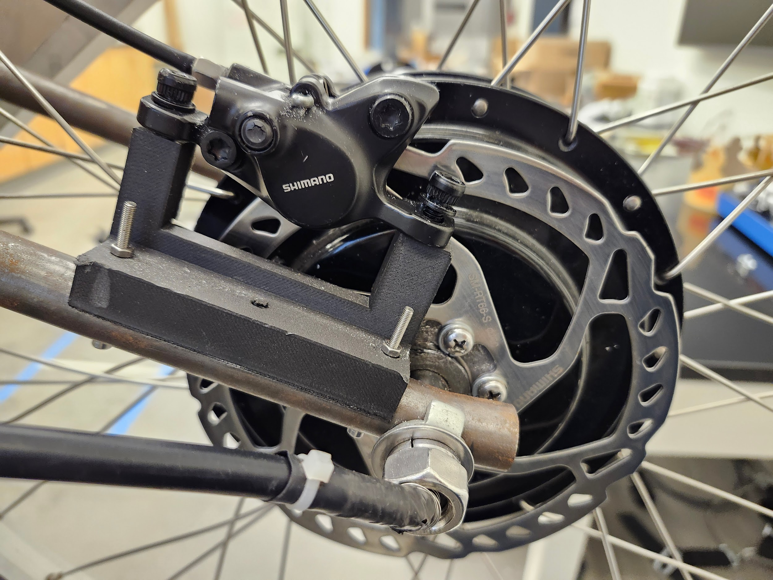
Figure 11. Image of the disk hydraulic brake installed in the rear wheel of the vehicle by the 2024 HFCV team. The calipers are held by a 3-D printed structure screwed onto the wheel’s axle. The disk is mounted directly onto the wheel.

Since the rear wheel brake was installed and working, it was deemed more necessary to work on the brakes for the front wheels. Since the front wheels’ rims were custom made based on the previous work done by the 2024 HFCV team, they fitted specifically to the disk used previously which is the Shimano SLX RT66 160mm rotor. This rotor is specially designed to work with the Shimano MT-200 brakes, and as such those were the brakes selected for the front wheels. This meant that it was necessary to take hand brakes designed for bicycles and adapt them into a pedal that could be pushed by the foot of the driver. Two prototypes and a final design were made to accomplish this.

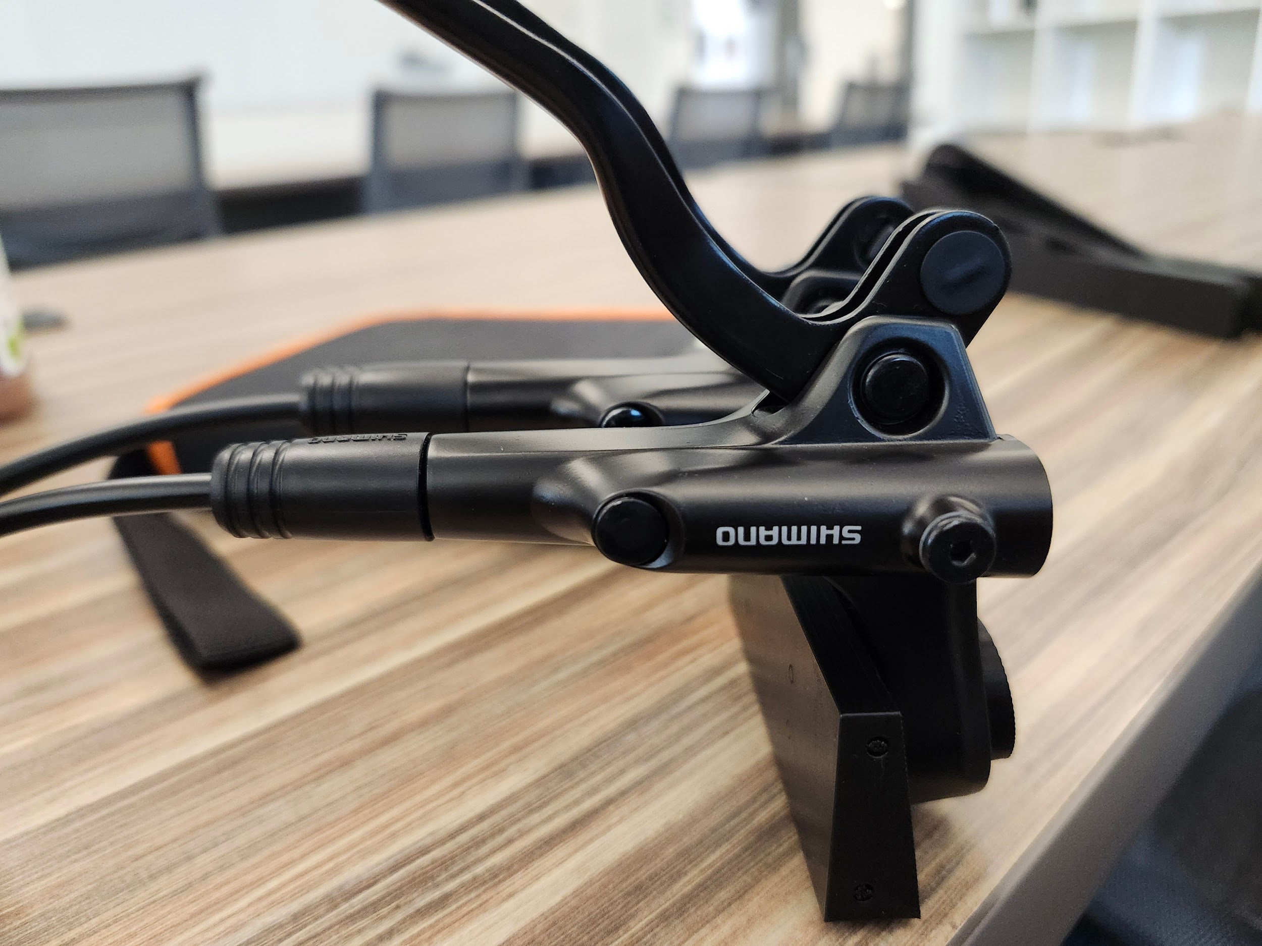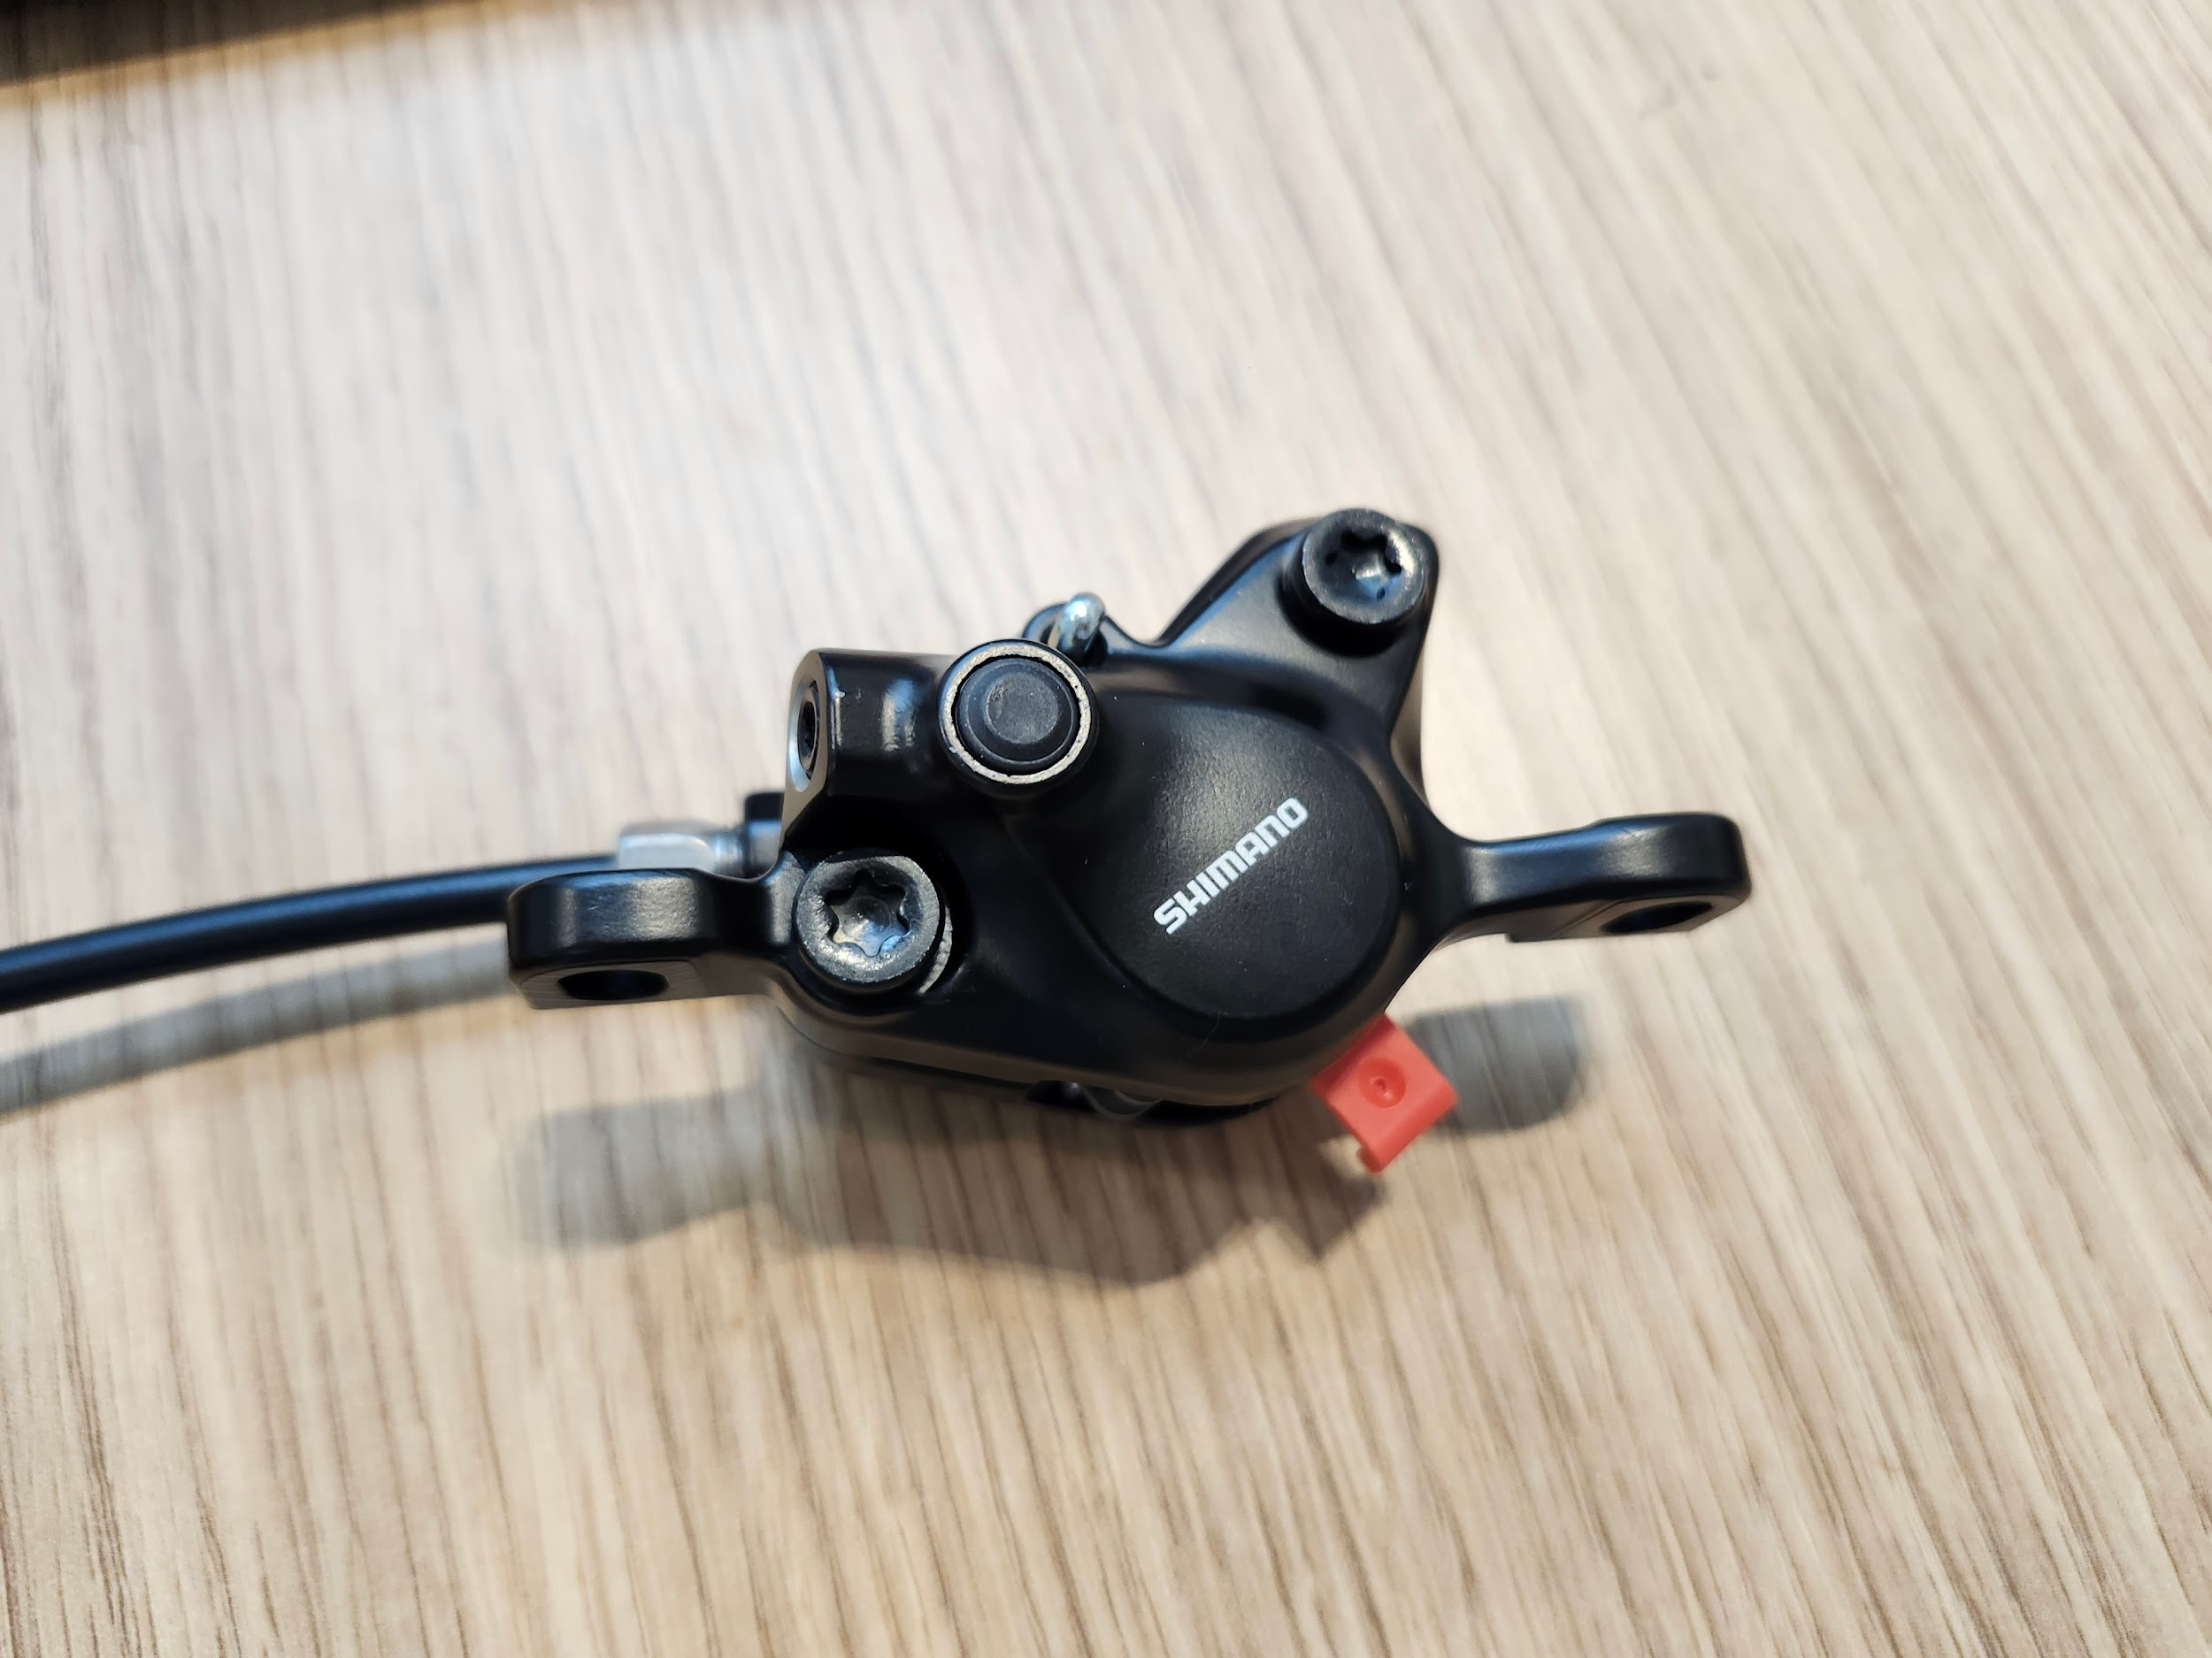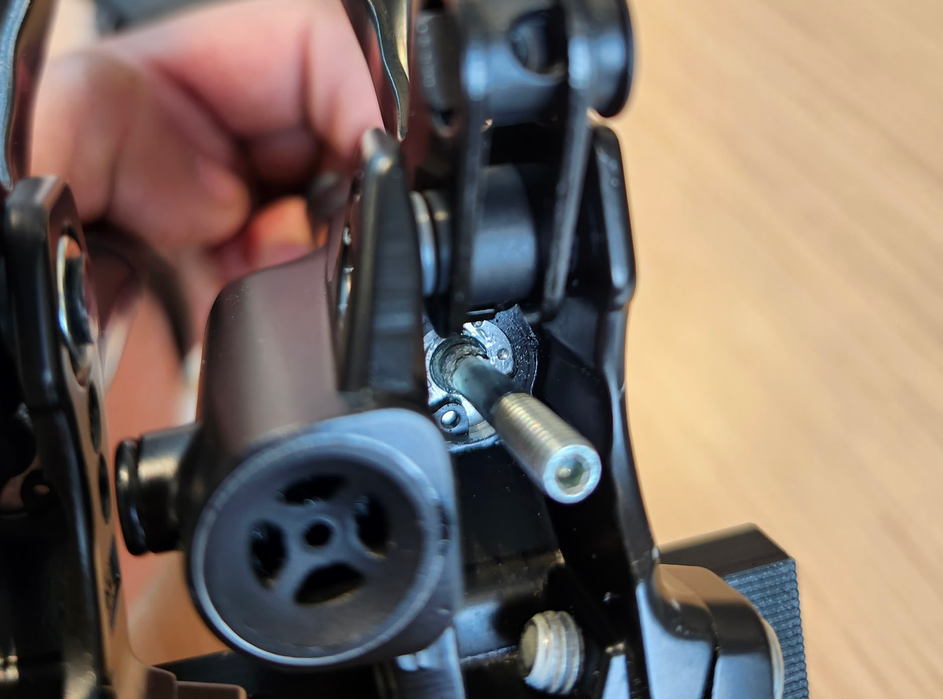
Figure 12. Images of the hand brakes selected for the front wheels of the vehicle. The master cylinder/handle is shown in the image on the left, the calipers are shown in the image on the middle, and the main piston’s rod (and what connects ultimately directly to the pedal) is shown in the image at the right. The brakes blades were disconnected from the main piston and pushed out of the way without fully disassembling them.

The first prototype shown in figure 13 drew inspiration from an image found on the internet. The design was made with a big compression spring that would push the pedal back to give a more responsive feeling to the brakes. However, this initial concept did not leave enough space for the actual brakes to be integrated and as such needed modifications.

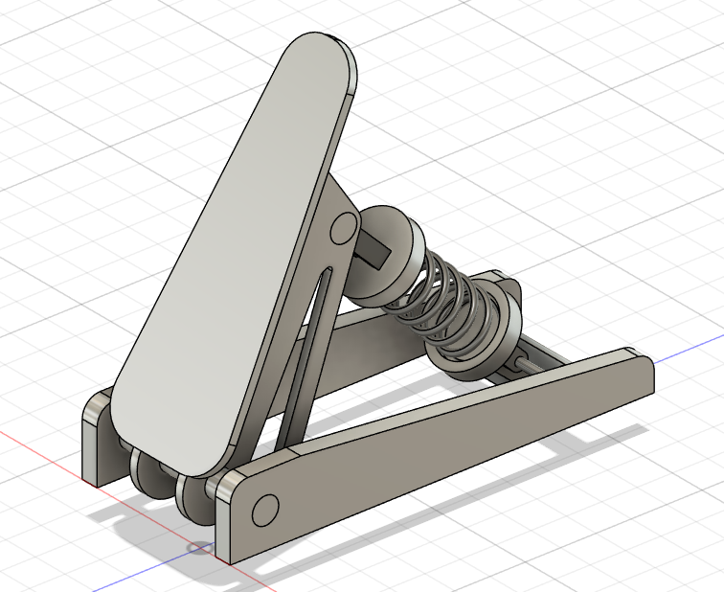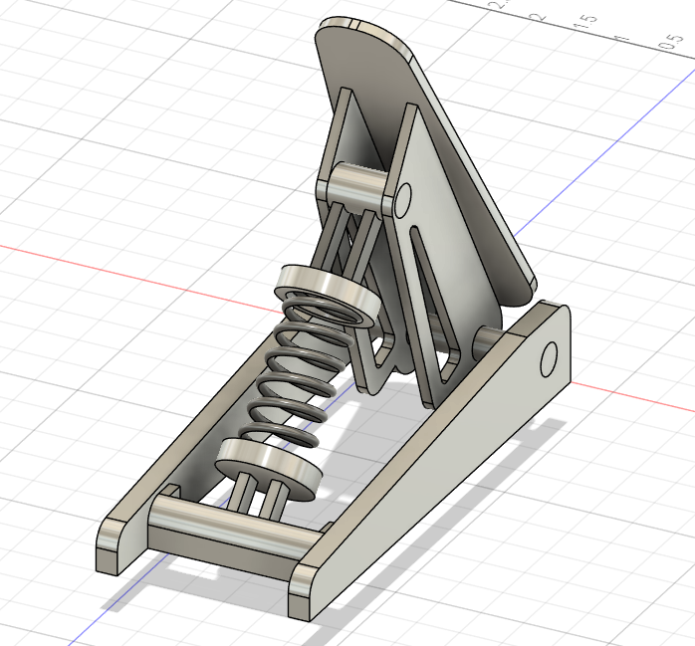
Figure 13. Initial prototype for integrating front wheel brakes into a pedal format. The compression spring would provide additional support and resistance to the brake to improve the feeling and responsiveness of the pedal. The design acts on a single pivot point where the stand and the pedal connect. The spring is also able to rotate in both connections to be able to hold straight.

Although this design was mostly scrapped, it served as inspiration for the final brake pedal.
The second prototype is shown in figure 14. This design uses two main levers, one acting as the pedal itself and the other would push the brakes. This would allow for no real modifications on the actual Shimano brakes, only requiring them to be installed in a specific way. A torque spring would also need to be installed to return the pedal to its initial position and a stopper would be added so that the driver wouldn’t accidentally damage the brakes by pushing the pedal too hard.

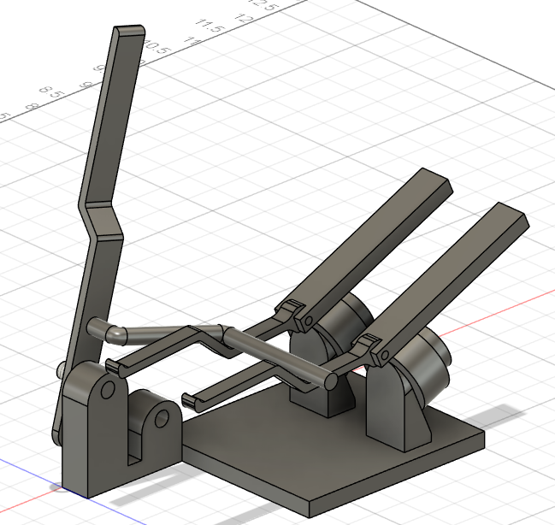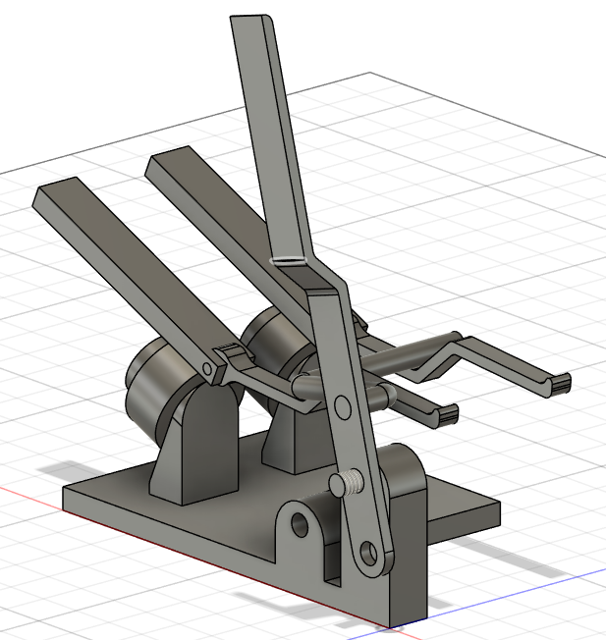
Figure 14. Second prototype for integrating front wheel brakes into pedal format. The main lever arm acts as the actual pedal that the driver would push. A second lever rigidly connected to the main lever would push the blades of the brakes down, activating the brakes. A specialized stand would hold the brakes at an angle to have the blades stand horizontal as their initial position. The stand holding the main lever has an additional hole to hold a torque spring to push back the lever to its initial position.

The issue with this second prototype is that it would not have a rigid connection to the brakes. Thus, it would be possible for the brakes to get stuck or take too long to decompress. This would mean the pedal would be very unresponsive to the driver and could be potentially dangerous. Additionally, too many of the components could potentially interfere with the driver or the driver could accidentally damage them. Thus, this design was also scrapped.
The final version of the brake pedal takes inspiration from the two prototypes. It takes the overall original design from the first prototype while replacing the compression spring with two torque springs from the second prototype. This final version allows for the rigid connection between the pedal and the brakes through two 4M female ball rods. The pedal is designed to hold the ball rods 0.60 inches from the main pivot point. This is because the brakes can be compressed approximately 0.3 inches and are able to be moved vertically by 0.1 inches. Placing the ball rods 0.60 inches from the main pivot point means that when rotating the pedal by approximately 30 degrees, it would push the brakes the desired distance of 0.3 inches. The ball rods being able to rotate due to a shoulder bolt also means that the connection with the brakes can always remain parallel.

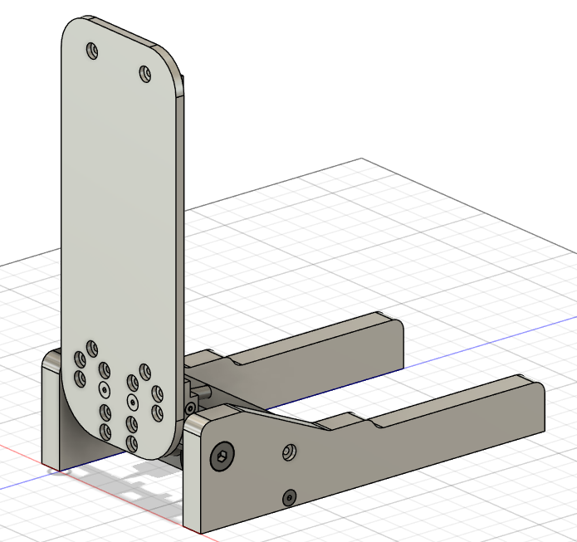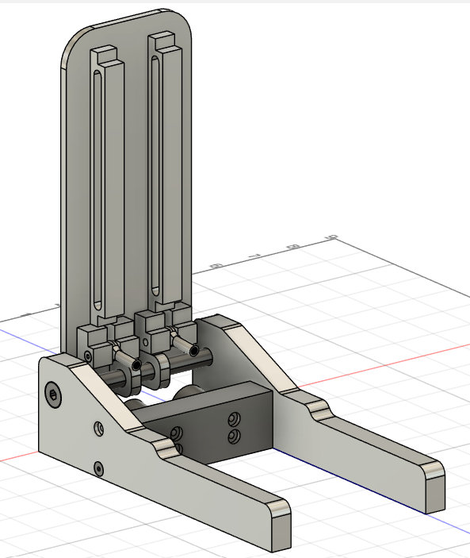
Figure 15. Final version of the pedal adaptation for the Shimano bicycle brakes. A half an inch diameter shoulder bolt holds the pedal and connects the two stand pieces together. The two zinc-plated steel ball rods connect directly to the brakes allowing for a rigid connection between the pedal and the brakes. The shoulder bolts holding the ball rods allow for rotation, meaning the ball rods are able to maintain a parallel connection with the brakes. An aluminum piece between the brake stand holds the brakes directly as if it was a bicycle handle. Zinc-plated steel screws are used to hold the components together.

The pedal can be held into place in the shoulder bolt by retaining rings. For this, small crevices can be made into the shoulder bolt for placing the retaining rings. If torque springs were deemed necessary, they could be installed in a similar way. However, initial testing should be conducted before deciding on whether or not to use the springs.
All the main components of the pedal are designed to be made individually and then screwed together. This is to make the manufacturing process more simple and also more material efficient. The columns seen in the pedal are there for support to make sure it resists deflection. Finally, the stand is made longer to disperse the force applied to the pedal over a larger area. It also provides space for further developments if needed and also for l-brackets to be attached to connect the pedal directly onto the frame.

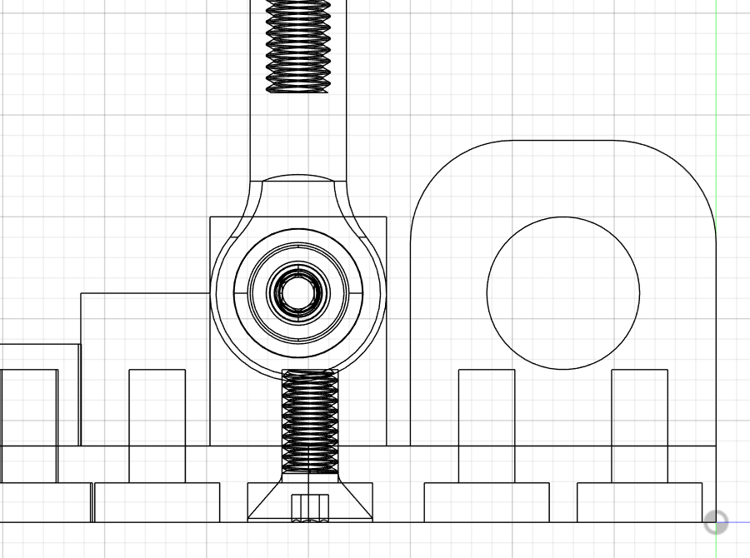
Figure 16. Image shows the main pivot point (right) as well as the pivot points for the ball rods. The image demonstrates the inside of the components having tapped holes for the screws connecting it to the main pedal piece (bottom).

Quick Release Steering Wheel Application
The steering wheel for the old design of the vehicle consisted of a pvc pipe being held by metal aluminum rods with a designed and fabricated rack and pinion system. During the summer of 2024, a new and more modern steering system along with the steering wheel was purchased. This new steering wheel adheres to the rule in Article 32 Steering, that states the steering wheel must be intuitive and precise. This new steering wheel also provides additional turning radius as the driver will not be in the way of the steering wheel, such as it was in the previous design.

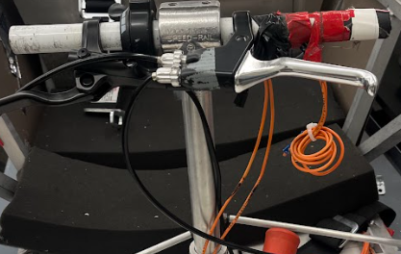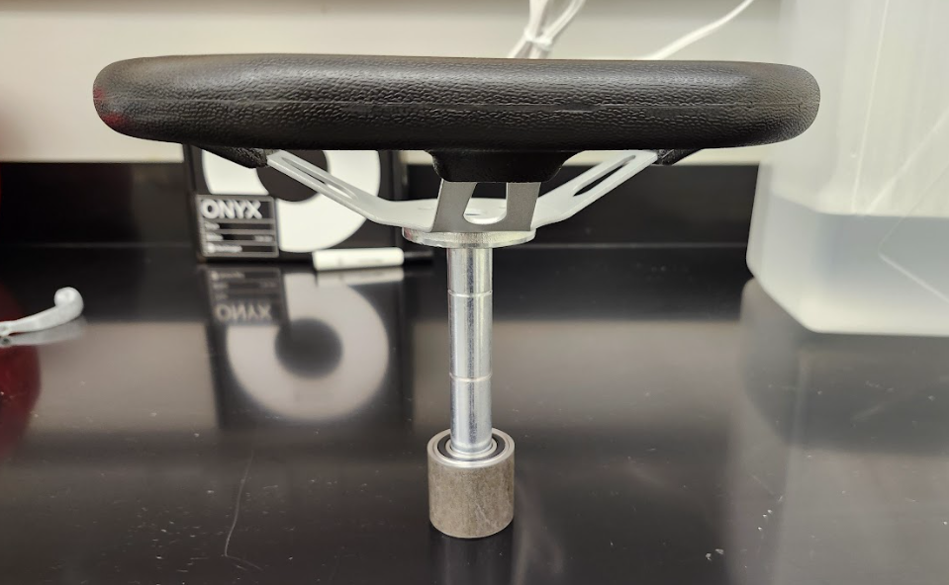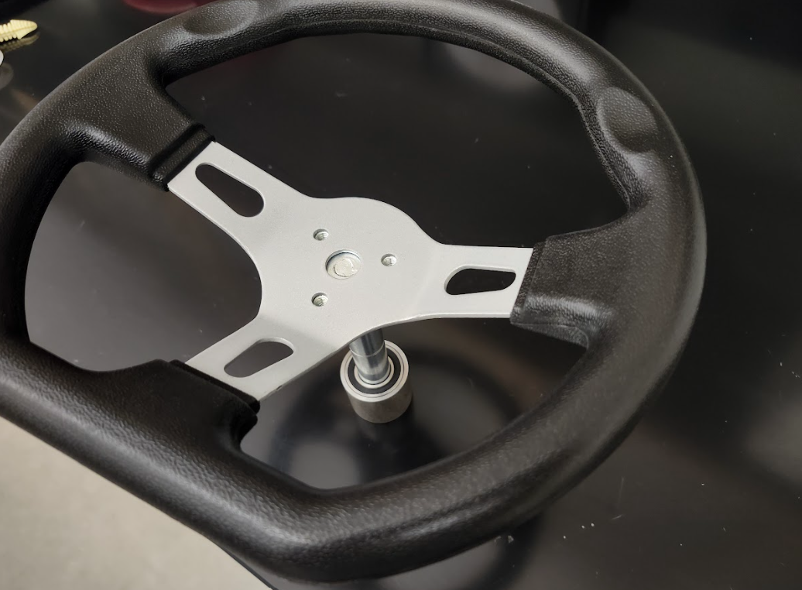
Figure 17. The steering wheel design of the old system can be seen in the leftmost image. It consists of a pvc pipe with a fabricated rack and pinion system. This steering wheel holds the braking system as well as the accelerator. The middle and far right images show the new steering wheel purchased in the summer of 2024. The steering wheel is modern and ideal for the design of the new car and adheres to the competition's rules and regulations.

The old design of the vehicle had many issues with its design. Mainly, the old design was not easy to re-construct or alter as it was a fixed design, designed to fit specifically to the structure of the old vehicle. Due to this, there was no way to alter the design, and thus, a new design implementation was needed (also given that there was a new steering wheel). This old design also compromised the safety of the driver as its placement made it very difficult to enter the vehicle and exit. In case of any emergency situation before, during, or after the race, the driver must be able to exit the vehicle as quickly and safely as possible. This design did not not meet those safety standards.
The new steering wheel, given that it was bought in the summer of 2024, needed to be modified in order to address all of the issues of the previous design. Also, the new steering wheel modifications needed to confirm to the team's design philosophy that the new system must be easy to modify, change, or be removed. We understand that our designs by no means are perfect, and thus we need to allow for future teams to change or modify our designs with ease.
First, the main concern with the old steering wheel was that it compromised the safety of the driver as it made it very difficult to enter and exit the vehicle. Therefore, the new design needed the steering wheel to not be in the way of the driver as they either entered or exited the vehicle. If the steering wheel was designed to be inside the frame of the car, wouldn’t this still compromise the safety of the driver as the steering wheel would still be in the way? The answer to that question is YES. So, how does one make the steering system both be inside the frame of the car and simultaneously outside of it? In response and inspired by Formula 1 vehicles, as seen in figure 18, the team designed a quick release steering system that is optimal for driver safety. Quick release is a steering wheel assembly that allows for the wheel to be easily inserted and removed from the steering column. Formula 1 vehicles specifically use this design to allow for drivers to enter and exit a vehicle with ease, prompting driver safety in case of an emergency.

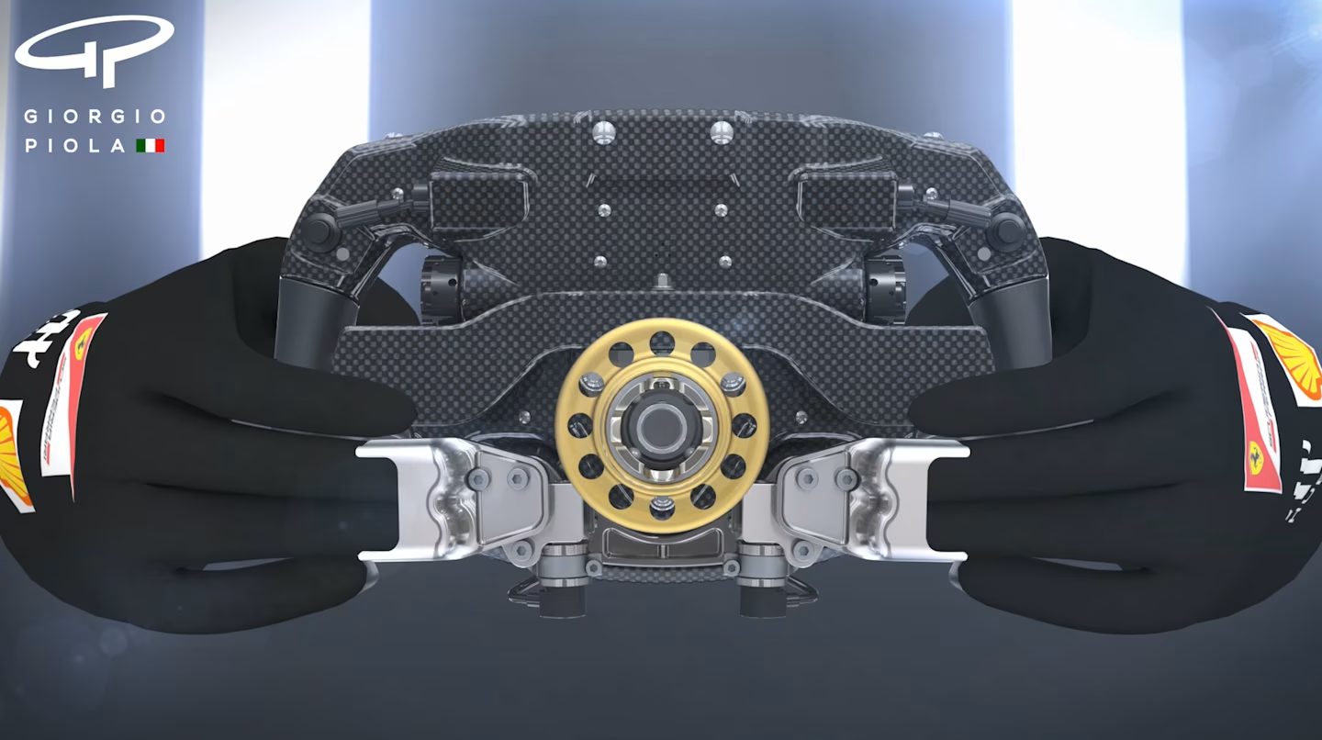
Figure 18. The image seen above displayed the quick release mechanism of a F1 vehicle. The design shows the golden ring with holes which is inserted into the column, and locks the steering wheel in place.

Prototype one, for the design and implementation of our quick release system mainly focused on the locking mechanism. As noted by one of our advisors, J. Johnson, quick release mechanisms for road-legal vehicles (including Formula 1 vehicles) typically have an electrical locking mechanism that grasps the column of the steering wheel with its ball joints inserted into the system. This prevents the steering wheel from coming off as the driver is performing maneuvers on the road. Given that our team wanted to make our design easy to manufacture and alter, we decided to design a system with a purely mechanical locking mechanism. This means that the system would lock into place through a system of open and closed pins by twisting the steering wheel into place. Figure 19 depicts the turning mechanism on the left hand side and the inspiration for a quick release CAD design on the right hand side that was obtained online.

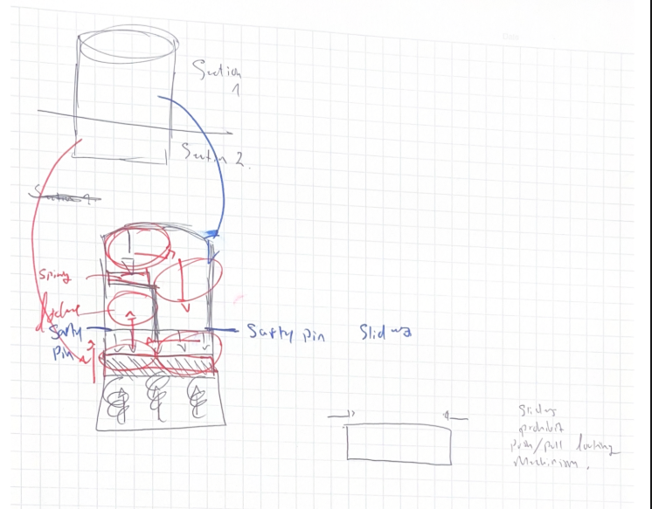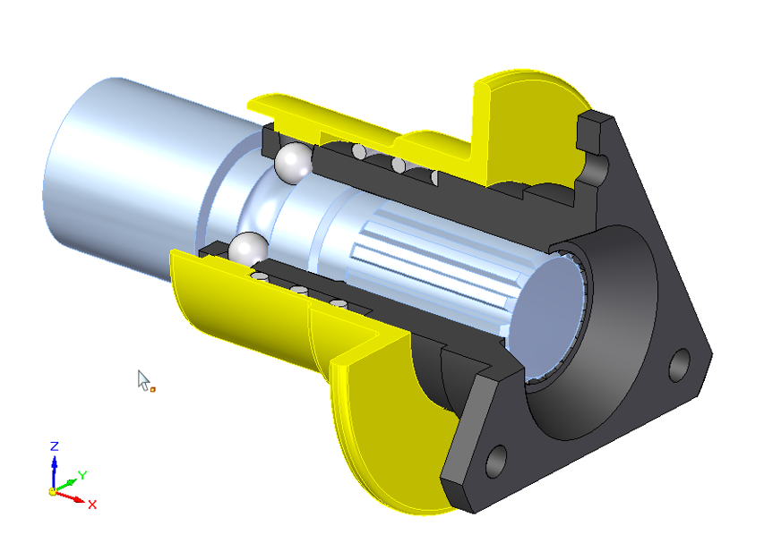
Figure 19. The locking mechanism can be seen on the left hand side. The system depicts a series of twists and turns that allows for the steering wheel to be moved into its locking state. Springs will push upward to keep the system locked, and can be pushed back to twist and unlock the wheel. The CAD design on the right hand side is the inspiration for the final design. It shows its locking components and quick release hub.

The issue with prototype one is in the integration of the system. The locking mechanism is designed to specifically be a permanent component of the steering wheel column. This can be seen in figure 19 on the CAD design upon which we decided to modify to fit our system. The steering column of the CAD design is made to fit specifically on the quick release hub, something the team took into consideration during the design process. However, this design contradicts our philosophies, given that this design is not easy to manufacture and does not allow for future changes. This is because the steering column would be permanently modified. Therefore a new design was needed, while maintaining the pure mechanical locking system that was constructed.
Prototype Two, and the final design for the quick release system addresses the issues of the first prototype by making the mechanism completely removable. The final design is a wrapping mechanism that slides into the column of the steering wheel and is held in place by external retaining rings. These rings are small and durable that are placed inside small grooves along the steering column at the ends of the components to hold them in place. This allows for the quick release designed hub to be accessible for modification or removable without compromising the overall integrity of the original steering column. The quick release design is made to fit the diameter of the steering column of 1.65 in (or 42.00 mm).

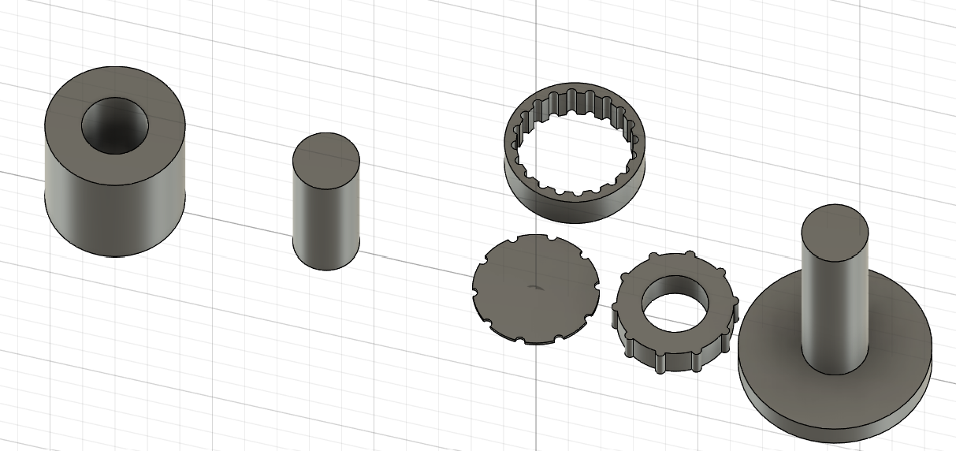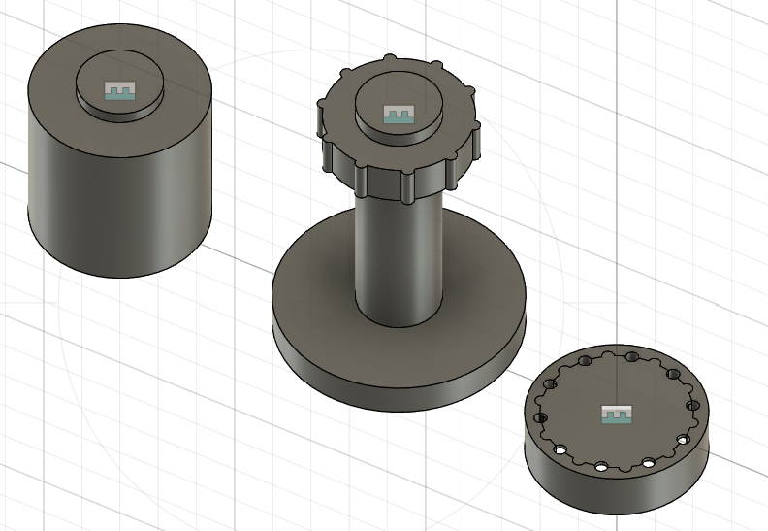
Figure 20. Images show the steering column along with the quick release steering mechanism. The cylindrical ridges placed onto the column in the right hand image slide into the open holes of the component the right of the column and twist into groves as seen inside of the ring on the leftmost image. The component to the left of the column in the rightmost image is a piston spring that pushes against the column to lock it into place. To remove the steering wheel, push down into the wheel and twist the column again to allow for the ridges to go through the opening holes of the ring.

This final design for the quick release system meets the technical specifications that the team focused on accomplishing. The system ultimately serves its purpose of being a quick release mechanism that allows for the driver to enter and exit the vehicle with ease. This adheres to, and resolves the teams goal to aim for a design without compromising the safety of the driver. This design also meets the requirements of the competition as the steering wheel needs to be held by two hands to drive, and gives a larger turning radius - allowing for the required 8 meter minimum turning radius as stated in Article 42. This design is also easy to be removed in a scenario where future modifications are needed to be made, or if the system becomes unfit and must be scrapped. To do this, simply remove the retaining rings and slide the components off. No permanent changes were made to the steering column because the system is a wrap made to fit around the given system.

Rack and Pinion Integration
During the first years in construction of the HFCV the rack and pinion system was fabricated to ideally fit into the frame of the designed vehicle. This “rack and pinion system” is attached to an aluminum pipe controlled by the steering wheel that when rotated, two thin aluminum rods connected to the suspension system and the wheels move latterly, causing rotation in the wheels. This design is unfortunately not up to our teams standards, but more importantly to the competitions regulations and rules. Essentially, the previous design limits the cars maneuverability and doesn’t give the vehicle the desired 8 meter turning radius, per the competition’s regulation as stated in Article 42. This system also cannot be modified or changed, which is not acceptable to our team’s goals and design approach.
A new rack and pinion system was bought in the summer of 2024 to be applied into the new framework of the vehicle. This rack and pinion system is specifically made for a small all terrain vehicle. Therefore, in order to make it fit into the newly designed chassis of the vehicle, major modifications were needed to apply this system and meet the standard rules/regulations.

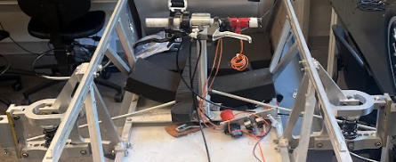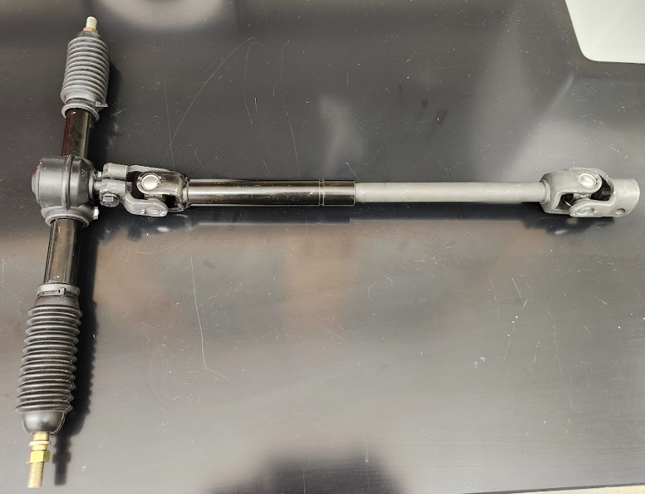
Figure 21. The rightmost image shows the old design of the rack and pinion system of the previous vehicle. As can be seen, it is rigidly connected to the system and designed to fit into that specific chassis. The leftmost image is the new rack and pinion system purchased in the summer of 2024. Design modifications are needed for proper application.

In the design process to appropriately integrate the new rack and pinion system, many considerations were taken into account. First and foremost, the attachment of this new system needed to be comfortable and not in the way of the drivers legs. A problem with the old design was that the thin aluminum rods scraped along the driver’s leg as the steering wheel was rotated. From prior experience in seeing the old vehicle being driven, the rack of the old design interfered with the driver experience and car performance. Therefore, the new design needed to address this issue by attaching the new system as to not impede the driver. Additionally, the rack and pinion system required minimal friction whenever the steering wheel was rotated. This means that the mechanism used to hold the pinion's intermediate shaft cannot simply grasp it as that would cause too much friction. Finally, to adhere to the team's principles, the modifications to this new design need to be accessible to future changes, easy to construct, and be removed with ease.
The final design modifications to the given rack and pinion system addressed the issues of the old vehicle and its limitations. The main constraint of the new rack and pinion system was designing a method to minimize the amount of turning friction as mentioned earlier. This design implementation required a piece to allow for a clamp to hold onto the intermediate shaft without causing a lot of turning friction due to two metals scraping with each other. The first approach to address this problem was using ball bearings that would slide into the shaft, and allow for a clamp to grasp onto it. By using bearings the clamp and the shaft would not interact. This would also improve the driving experience as it would make turning smoother. However, a limitation with ball bearings is that their lubrication properties are easily exposed. This allows dirt and other small particles to enter the bearings, thus affecting the lubrication. This problem will eventually lead to other issues that will internally damage the bearing causing premature failure and excess friction. As a result other methods were sought after and explored. The team eventually determined that bushings were a better alternative to ball bearings. Bronze bushings offer the same benefits the team sought in bearings, but are more reliable. This is because bushings are generally more cost effective and are self lubricating without excess exposure to dirt and other debris. The implementation of the bushings with the clamps applied can be seen in figure 22.

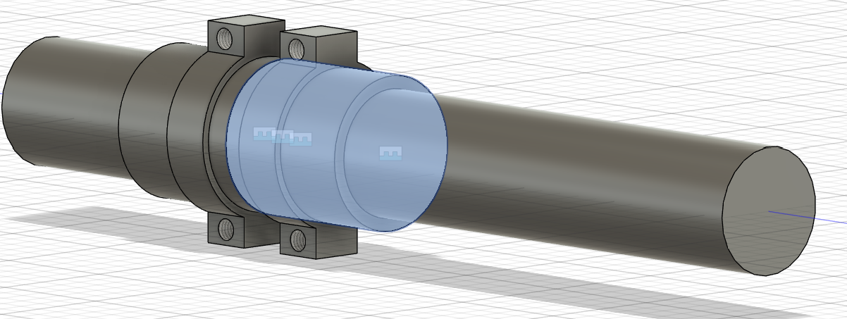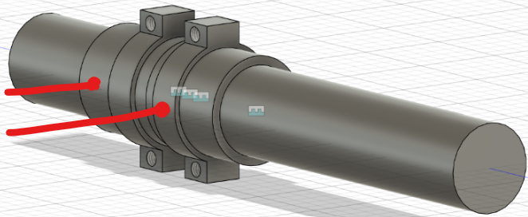
Figure 22. The top image shows the bushing around the intermediate shaft underneath a clamp. The right side image displays the clamps, which are the mechanism used to connect the shaft to the frame while holding it in place. The clamps are held together by screws, allowing the system to be removed with ease.

Given the design of the system and its modification, the other pending issue can be addressed, comfortability. Through the integration of the installed clamps, lightweight aluminum rods can be connected to the shaft to provide stability. The metal rods should be connected to the top edge of the chassis of the vehicle over a compression member so as to not interfere with the structural integrity of the frame. Small depictions of these rods are shown in figure 22 depicted by red lines. Overall, this design addresses the issue of comfortability, and improved driver experience by minimizing the amount of friction generated when turning the steering wheel.
Still, according to Article 42 of the rules and regulations of the Shell Eco Marathon, the design of the vehicle must complete a minimum of at least 8 meter radius turn. To obtain this radial turn the angle at which the wheels of the vehicle turn must be determined. This is because the angle of the wheel determines the arc length, which is proportional to the radius. In knowing the radius the car must turn, and assuming the inner wheel of the car will dictate the turning angle, the angle of the inner wheel can be obtained using the Ackermann steering model. Given that L = Wheelbase (The distance between the front and rear axle centers) [meter], R = Turning radius to the midpoint of the rear axle [Meter], $δ$ = Steering angle of both wheels equally, only assuming inner wheel since both wheels will turn the same amount (there is no need for a differential), we have:

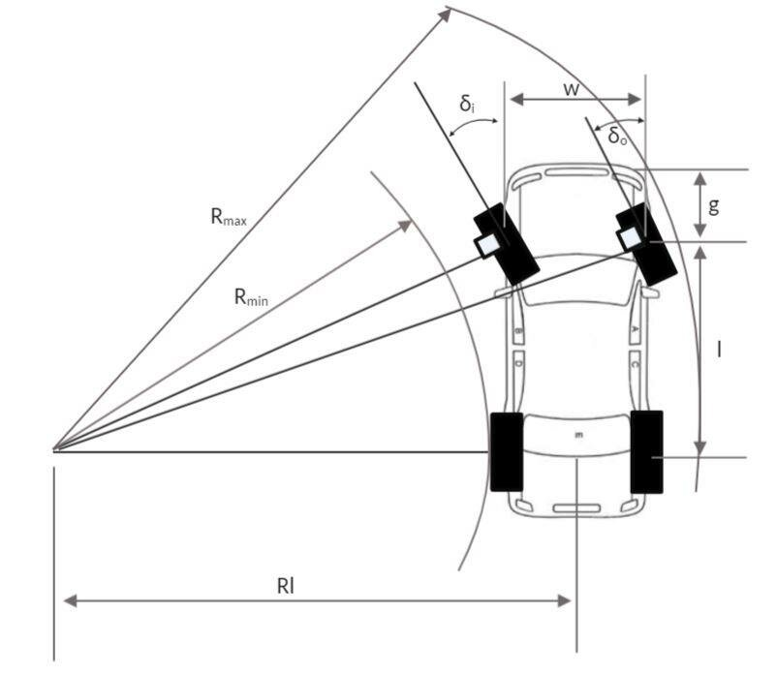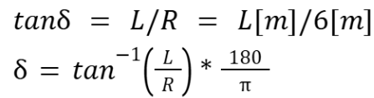
Figure 23. The image on the left represents the Ackermann geometry diagram. It shows the varying angles of the front wheels turning in accordance with other important measurements. The mathematical work on the right shows the resulting turning wheel angle $δ$ of the inner, and outer wheels.

Therefore, the turning angle $δ$ of the inner wheel is obtained. By knowing this angle, the length of the legs of the rack can be elongated to fit the new frame of the system. Currently, the rack and pinion is too short and doesn’t allow for the wheels to be perfectly attached. An easy fix to solve this problem is simply to slice the legs and weld a new metal in between the sliced legs. This will elongate the system giving you the necessary wheel angle to meet the rules presented in Article 42.
The final design modifications to the rack and pinion system optimize the new given system purchased in the summer of 2024. The changes to the system keep the team's principles of designing mechanisms that are easy to change and manufacture, while also addressing several issues of the previous vehicle’s designed system. When integrated into the new frame, the system will be efficient and optimal. If any further changes are needed to be made, the design of this system is viable for any modifications and easy to remove.

Conclusion

For the past academic year the team has strived towards major progress in the effort to continue the revitalization effort of the Shell Eco-Marathon HFCV commenced by the E90 team in the academic year of 2023-2024. Countless hours were spent studying their work, and the work of teams many years prior. Our efforts to continue in this race are a mere reflection of all the hard work that past teams have put into this vehicle. Our goal with this project was to acknowledge the past, and build off of efforts and designs to create our own unique blueprints. In doing so, we recognize and respect the immense design project that the Shell Eco-Marathon is. Especially all the effort done to jumpstart this project once more. The team this year focused primarily on mechanical design and integration of new systems to improve the vehicles performance. Throughout the design process, the team developed a philosophy - learning from past mistakes - the team focused on designing parts that were easy to modify, replicate, manufacture, and or remove. We recognize that our ideas and designs are not perfect, and that someone down the road may have better solutions to problems we sought to solve. Although the team worked on separate areas of the vehicle, the team worked together and bounced ideas to make everything come together at the end. As a result, the final products that the team produced worked efficiently, but most importantly, adhered to our design principles.

Suspension System Efficiency
The new suspension system was successful in what it was hoped to achieve. The stiffer and larger shock absorber provides more space to reduce vibrations and absorb impacts from the road. This all so that the driver is able to have as smooth of a drive as possible. The reduction in vibrations should also help maintain the vehicle together, as these vibrations are often the reason for which screws come apart or systems could malfunction. Finally, the new suspension allows for fine tuning. Once the vehicle is fully built, if it is found the shock absorber is too stiff, too long, or too soft, it can be easily interchanged for a more efficient one. This provides significant flexibility to the project which was very needed.

Hydraulic Brakes
The integration of the hydraulic brakes system to the vehicle can be considered a success, as the goal for developing a way to put the brakes into a pedal format was achieved. As with the suspension, the brakes might need additional fine tuning once the vehicle is fully completed. However, this is just for driver feel and comfort as the brakes should be fully functional. If further developments are needed, the current design should aid the process due to its flexibility to change parts. It is hoped that the design of the pedal can also be used for developing an accelerator pedal, with some modifications to satisfy the new system.

Steering Wheel Quick Release Efficiency
As a final product, the quick release steering system development was a success that met all of our goals. The system increases the safety of the driver in case of an accident because of its nature. As mentioned several times, the quick release steering wheel allows for the wheel to be attached and detached within seconds, ensuring a quick exit from the vehicle. In this regard, the overall safety of the vehicle was improved in comparison to the old designs. It is notable to also recognize that the system can be easily removed from the steering wheel. This is because the components slide into and around the steering wheel column. Instead of permanently altering the steering wheel, the team sought to make the design accessible to modifications.

Rack and Pinion Development
Our final rack and pinion system included new components that made it compatible with the new development of the chassis and the suspension system. The rack and pinion system intruded bushings to provide the driver a smooth driving experience, while also not hindering the overall performance of the vehicle. The bushings made it possible to attach a clamp onto the steering shaft that would connect to the top frame of the chassis. In doing so, the overall steering would not be in the way of the driver making it uncomfortable, nor limiting the car's ability to steer. These components met the steering system rule found in Article 42 of the Shell Eco-Marathon competition rule book. Finally, in accordance with the new suspension system, the rack and pinion system was elongated to fit the new frame and allow the wheels their appropriate turning angle. The development of this system is also subject to modifications and any changes. Future teams will be able to completely remove the system with ease and fit in their better alternative to our team's approach.

Future Work

The Race To The Finish Line
As much as the team would have loved to compete in the Shell Eco-Marathon this year, the amount of work and further developments needed to win the race are far from done. The team was able to progress and steer the development of this project further, building upon the work of our predecessors. We hope that the developments the team has done can help push the HFCV to the finish line, however, work must still be done. In order for future teams to continue working on this project the team has developed a game plan that we believe will pave the road to success.
First and foremost, due to shortage of time and access to the machine shop, the team was unable to manufacture a few of the components that were designed. It is integral to have these components made as they are the backbone to the development of the chassis. For instance, the design and development of front suspensions were made, however, only one out of the two were constructed. In order to continue any further developments and testing, both front suspension need to be built and applied to the new chassis. In doing so, the total width of the vehicle can be measured, which would allow for the rack and pinion system to be elongated adequately and installed along with the quick release steering system and the breaking petals.
From the development of the front suspension system, the team observed that the rear suspension is not up to standard and must be upgraded. The rear suspension is far too weak and will prove inadequate if taken to competition. The team hypothesizes that the current rear suspension will experience the same vibrations as the previous old front suspensions. If the key to winning the race is to be as efficient as possible, limiting these vibrations through a new suspension integration, although small, will prove great results.
Furthermore, the integration of the accelerator/brake pedal must be installed. This is crucial because it is a new rule that all vehicles must have foot pedals. If this standard is not met, the vehicle will not be allowed to compete in the race. Designs for these components were developed by the team and pushed in an appropriate direction. Application of these components will be crucial to their further development, but most importantly, to pass the competition’s strict rules.
Finally, aside from the mechanical and electrical components of the vehicle, the aerodynamic cowl design needs to be addressed. Unfortunately, the team this year had no time to explore this area of the vehicle, yet we recognize its importance. It is essential to note that the purpose of the race is fuel efficiency. Therefore, the design of the cowl is of utmost importance given that the aerodynamic properties of the vehicle may either greatly improve the vehicle's efficiency, or hinder it. The team suggest that the design take inspiration from motorsport vehicles, and design the cowl with the shape of an inverted airfoil. In doing so, the air flow will create a downward force of the vehicle allowing it to slice through the wind in front. Other aerodynamic properties are essential to study and examine further to provide the vehicle with the best performance.
Overall, the vehicle is far from finished. There exists a lot of project options to pursue in order to make the vehicle competition ready. Further developments can be made to improve the designs made this year, and are most certainly welcomed. Afterall, the team focused on designing systems that were easy to modify, remove, recreate, and manufacture.

Acknowledgments

Throughout the development of this project there were many great individuals that contributed and supported our ambitions and strives towards meeting our goals. Whether that was through insightful feedback/commentary, helping us construct our designs, teaching us how to use CAD, etc, We greatly appreciate your support throughout the year.
Without a doubt, we would like to thank the Engineering Department staff and members at Swarthmore College for all of the help and support we received throughout the year. Your contributions to our efforts would not have been possible without your support. Especially Professor Carr Everbach, our instructor, who guided us through insightful feedback and gave us more resources than we could ask for. For that we are extremely grateful. We would also like to acknowledge J. Johnson, who guided us in the development of our designs by questioning our every attempt at finding a solution to our problems and being patient with us throughout the learning process. We always assumed we knew better until we went to J to ask for advice and realized our designs were not sufficient enough. Without him, our designs would not be at the high standard they are today and we would have not learned as much as we did throughout this project. Thank you for leading us in the right direction J.
Finally we would like to acknowledge Nora Jiang’27, who continued the project in the summer of 2024 and led the team in the right path. Without Nora Jiang by our side, the team would not know where to start or how to start. Your insights in the development of the car were truly appreciated. Jano Vasquez-Jaffe’26, who motivated the team to strive further into our goals by “hyping us up” constantly and for always offering a helping hand. Without Jano, the further development of the vehicle would be delayed as his insights and experience are truly appreciated. Last but not least, Thank you to all the members of the HFCV club who began to work on the construction of the chassis when the team did not have enough time to build it.
The team wishes the best of luck to all future members who will attempt to tackle this massive challenge and lead the team across the finish line. Thank you again to everyone for all your hard work, dedication, and support. THANK YOU!

Appendix

Sources
- “N Vision 74” Hyundai, https://www.hyundai-n.com/en/models/rolling-lab/n-vision-74.
Accessed May 15, 2025.
- “About Shell Eco-marathon” Shell Eco-marathon,
https://www.shellecomarathon.com/about.html. Accessed May 15, 2025.
- “Fuel Cells” U.S. Department of Energy,
https://www.energy.gov/eere/fuelcells/fuel-cells#:~:text=A%20fuel%2C%20such%20as%20hydrogen,creating%20a%20flow%20of%20electricity. Accessed May 15, 2025.
- “How Hydrogen Fuel Cells Work” Volvo Construction Equipment & Services California,
https://www.vcesvolvo.com/how-hydrogen-fuel-cells-work/. Accessed May 15, 2025.
- “Bimetallic or Galvanic Corrosion Importance” Global MasterClass,
https://globalmasterclass940778542.wordpress.com/2019/04/06/bimetallic-or-galvanic-corrosion-importance/. Accessed May 15, 2025.
- “Galvanic Reaction Chart” Grabber Construction Products,
https://www.grabberpro.com/LiteratureandResources/GalvanicReactionChart. Accessed May 15, 2025.
- “Dissimilar Metal Corrosion with Zinc” American Galvanizers Association,
https://galvanizeit.org/design-and-fabrication/design-considerations/dissimilar-metals-in-contact#:~:text=For%20example%2C%20avoid%20the%20use,to%20minimize%20galvanic%20corrosion8. Accessed May 15, 2025.
- “The Pros and Cons of Double Wishbone Suspension” Perform-Ex Automotive,
https://www.performexauto.com.au/blog/pros-and-cons-of-double-wishbone-suspension/?srsltid=AfmBOortf0i4rvWFf2Koi9eG43a-26L724A-K_Y2e4cE5npDD3JZh_p9. Accessed May 15, 2025.
- Kristyawan, Yudi & Muchammad, Asro. (2021). Early Detection of Overheating in
Motorcycle Disc Brakes Based on Arduino. Jurnal JTIK (Jurnal Teknologi Informasi dan Komunikasi). 6. 21-27. 10.25139/inform.v6i1.3348. https://www.researchgate.net/figure/The-components-of-a-disc-brake-on-a-motorcycle_fig2_353038824.
- “What is the difference between master cylinders?” Motovation,
https://www.motovationusa.com/what-is-the-difference-between-master-cylinders-. Accessed May 15, 2025.
- “F1 steering wheels: How they work, what the buttons do and more” Motorsport,
https://www.motorsport.com/f1/news/f1-steering-wheels-how-they-work-what-the-buttons-do-and-more. Accessed May 15, 2025.
- “Shell Eco-Marathon 2025 Official Rules” Shell Eco-Marathon,
www.shellecomarathon.com/about/global-rules/_jcr_content/root/main/section/simple_copy_copy_143/link_list/links/item0.stream. Accessed May 15, 2025
- “Indianapolis Motor Speedway Chooses Steel Slag For Its Durability, Strength and
Friction” Slag Successes, https://www.tmsinternational.com/docs/Indianapolis%20Motor%20Speedway%20Slag%20Successes.pdf. Accessed May 15, 2025.
- “Tech insight - Ferrari fine tune their tyre management” Formula 1,
https://www.formula1.com/en/latest/article/tech-insight-ferrari-fine-tune-their-tyre-management.5CSsjnn9p6EQOAIW6kow4Y. Accessed May 15, 2025.
- “Quick Release Steering Hub” GrabCad Community,
https://grabcad.com/library/quick-release-steering-hub--1. Accessed May 15, 2025.
- Gautam, Puneet & Sahai, Shubham & Kelkar, Sachin & Reddy D, Mallikarjuna &
Agrawal, Prajwal. (2021). Designing Variable Ackerman Steering Geometry for Formula Student Race Car. International Journal of Analytical Experimental and Finite Element Analysis (IJAEFEA). 8. 1-11. 10.26706/ijaefea.1.8.20210101. https://www.researchgate.net/publication/349289743_Designing_Variable_Ackerman_Steering_Geometry_for_Formula_Student_Race_Car/citation/download.

Spending and Budget
Table 3. Project spending and budget.
Specific System | Components | Cost
Suspension | - Thread-Locking Hex Drive Flat Head Screws (10 Pack) | - $5.26
Brakes | - Shimano MT-200(R) (2 ordered)  - SHIMANO SLX Rt66 Rotor (2 ordered)  - Alloy Steel Shoulder Screw (½” diameter, 3 ¾ long shoulder)  - Alloy Steel Hex Drive Flat Head Screws (50 Pack)  - Internally Threaded Ball Joint Rod Ends (2 ordered)  - Alloy Steel Shoulder Screws (2 ordered) | - $36 (each)  - $22 (each)  - $7.14  - $11.52  - $12.50 (each)  - $3.34 (each)
Steering | - Ultra-Low-Friction Oil-Embedded Sleeve Bearing (3 pieces) | - $8.73 (each)
Total |  | $197.79
Budget |  | $800

Note: The costs of the aluminum used for the manufacturing of each system is not accounted for as the materials were taken from the machine shop’s stock (thank you J!).
Prices for certain components might be different from the date of purchase. As such, replication of this work should be careful and account for current material costs.

Additional Diagrams
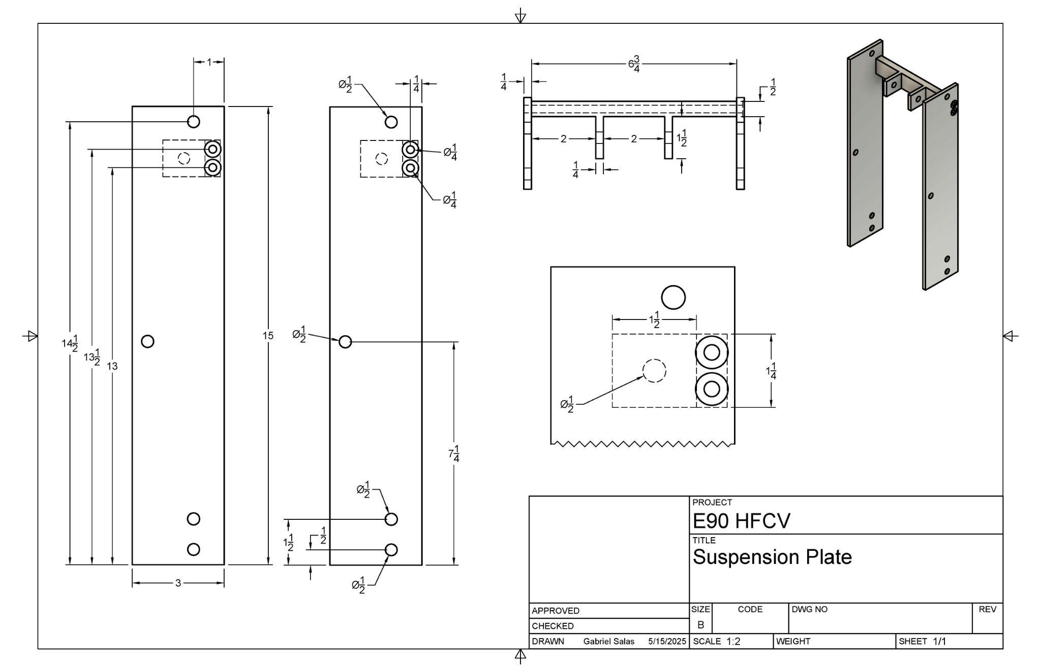
Figure 24. Drawing for the suspension plate. Dimensions are in inches.

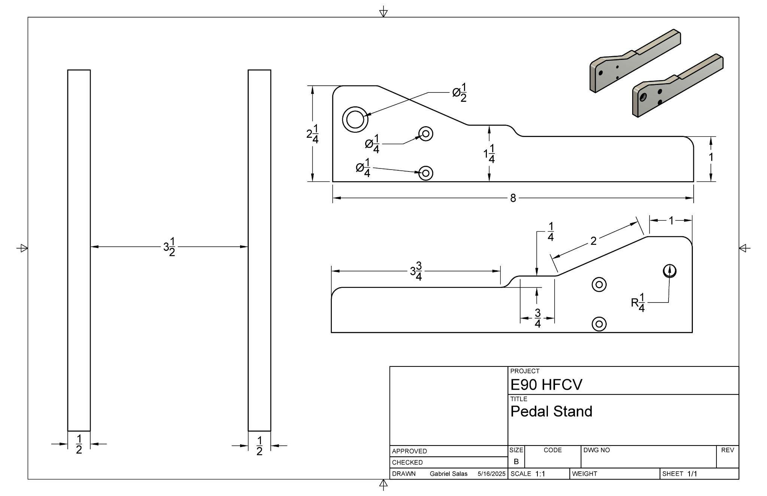
Figure 25. Drawing for the brake pedal stand. Dimensions are in inches.
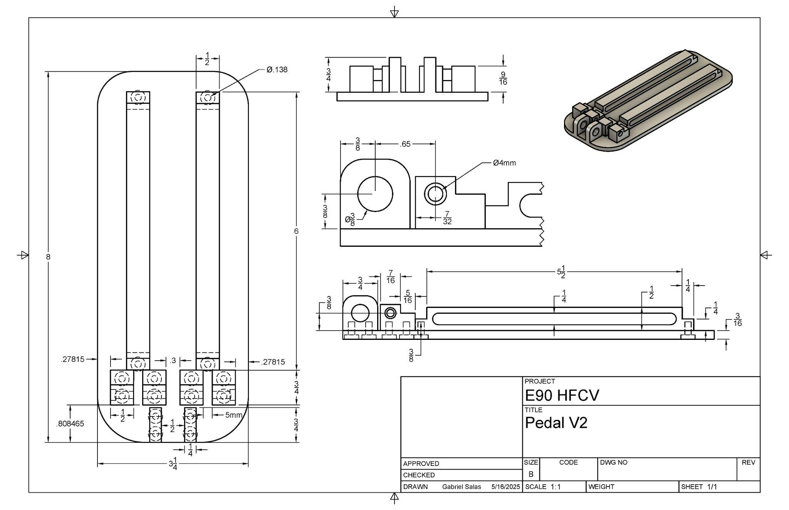
Figure 26. Drawing for the brake pedal. Dimensions are in inches with some specifications components in millimeters.

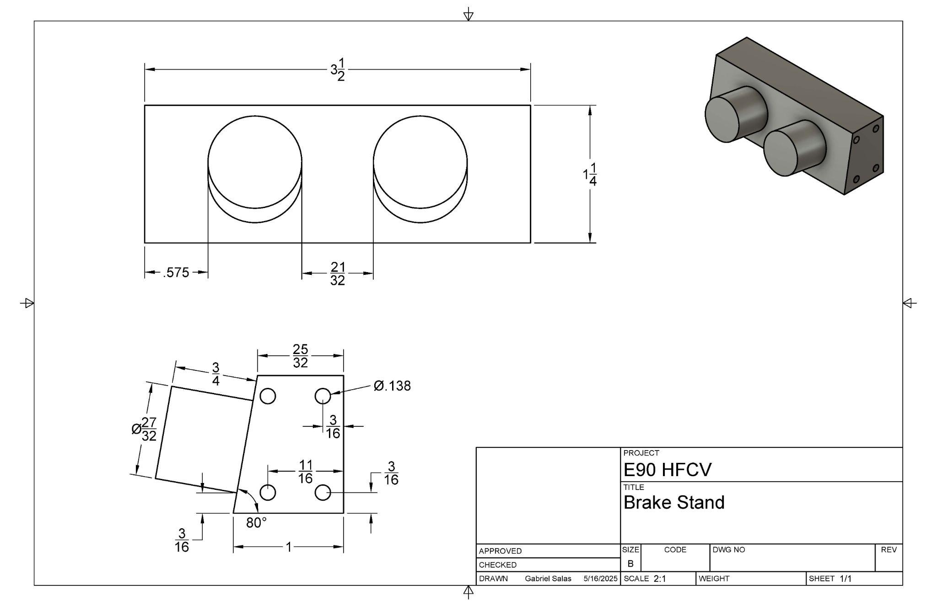
Figure 27. Drawing for the brake stand part of the pedal design. Dimensions are in inches.
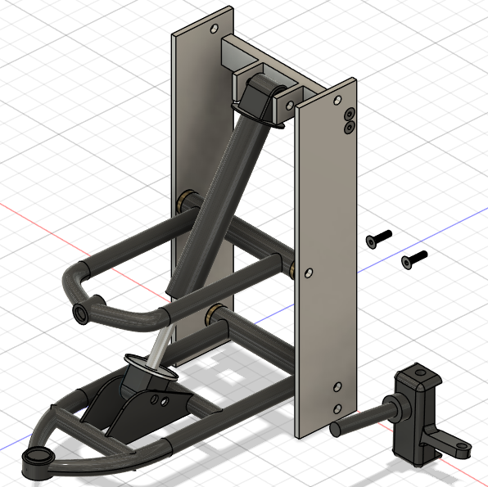
Figure 28. CAD model for the double wishbone suspension and suspension plate system. Primarily used for physics testing and visualization. Model is not in the exact dimensions of the physical system.

“N Vision 74” Hyundai
“About Shell Eco-marathon” Shell Eco-marathon
“Fuel Cells” U.S. Department of Energy
“How Hydrogen Fuel Cells Work” Volvo Construction Equipment & Services California
“Bimetallic or Galvanic Corrosion Importance” Global MasterClass
“Galvanic Reaction Chart” Grabber Construction Products
“Dissimilar Metal Corrosion with Zinc” American Galvanizers Association
“The Pros and Cons of Double Wishbone Suspension” Perform-Ex Automotive
Kristyawan, Yudi & Muchammad, Asro. (2021). Early Detection of Overheating in Motorcycle Disc Brakes.
“What is the difference between master cylinders?” Motovation
“F1 steering wheels: How they work, what the buttons do and more” Motorsport
“Shell Eco-Marathon 2025 Official Rules” Shell Eco-Marathon
“Indianapolis Motor Speedway Chooses Steel Slag For Its Durability, Strength and Friction” Slag Successes
“Tech insight - Ferrari fine tune their tyre management” Formula 1
“Quick Release Steering Hub” GrabCad Community
Gautam, Puneet & Sahai, Shubham & Kelkar, Sachin & Reddy D, Mallikarjuna & Agrawal, Prajwal. (2021). Designing Variable Ackerman Steering.

